**We_Secure: Lost and Found**

**UCS503 Software Engineering Project Report**

**End-Semester Evaluation**

**Submitted by:**

102003346 Vanshaj Singla

102003347 Chayan Sinha

102003355 Karan Singla

BE Third Year, COE

Group No: 14

**Submitted to:**

**Ms. Arwinder Dhillon**



**Computer Science and Engineering Department**

**TIET, Patiala**

**December 2022**

# TABLE OF CONTENTS

|  |  |  |
| --- | --- | --- |
| **S. No.** | **Assignment** | **Page No.** |
| **1.** | **Project Selection Phase** |  |
| 1.1 | Software Bid | 4 |
| 1.2 | Project Overview | 6 |
| **2.** | **Analysis Phase** |  |
| 2.1 | Use-Case Templates | 12 |
| 2.1.1 | Use Case Diagrams | 14 |
| 2.2 | Swimlane Diagrams | 15 |
| 2.3 | Data Flow Diagrams (DFDs) |  |
| 2.3.1 | DFD Level 0 | 16 |
| 2.3.2 | DFD Level 1 | 16 |
| 2.3.3 | DFD Level 2 | 17 |
| 2.4 | Software Requirement Specification in IEEE Format | 18 |
| **3.** | **Design Phase** |  |
| 3.1 | Class Diagram and Object Diagram | 24 |
| 3.2 | Sequence Diagram | 25 |
| 3.3 | Collaboration Diagram | 26 |
| 3.4 | Database Design: ER Diagram | 26 |
| 3.5 | State Chart Diagrams | 27 |

# TABLE OF CONTENTS

|  |  |  |
| --- | --- | --- |
| **S. No.** | **Assignment** | **Page No.** |
| **4.** | **Implementation** |  |
| 4.1 | Component Diagrams | 28 |
| 4.2 | Deployment Diagrams | 28 |
| 4.3 | Screenshots of Working Project | 29 |
| **5.** | **Testing** |  |
| 5.2 | Test Cases and Test Report | 40-42 |

**1.1 Software Bid/ Project Teams**

**UCS 503- Software Engineering Lab**

Group : 3CO14 Dated: 04.08.2022

**Team Name: The Invincible’s**

**Team ID (will be assigned by Instructor):**

Please enter the names of your Preferred Team Members. :

* You are required to form **a three to four person** teams’
* Choose your team members wisely. You will not be allowed to change teams.

|  |  |  |  |  |
| --- | --- | --- | --- | --- |
| Name | Roll No | Project Experience | Programming Language used | Signature |
| Vanshaj Singla | 102003346 | Grocery Distribution Website for NGO (JPMC), Hostel Swapping Database  Management System , E-  Tender website for easing govt. e-procurements, Path ollower Robo-Car. | HTML , CSS , C++,  Bootstrap ,  J a v a S c r i p t  Python, SQL , P L / S Q L ,  Arduino . |  |
| Chayan Sinha | 102003347 | Library Management System ,  Portfolio Website, Bangalore  Food Bank Website , Automatic Soap Dispenser(Arduino based),  RoboCar (Buggy)  Car Pooling Website  WE_SECURE  Mess_Management System(DBMS) | HTML,CSS,C++  Bootstrap ,SQL , PL/ SQL ,Python, Arduino.JavaScript. |  |
| Karan Singla | 102003355 | Hostel Swapping Database Management System , Line follower RoboCar. | C++, Python, SQL, PL/SQL , Arduino. |  |

**Programming Language / Environment Experience**

List the languages you are most comfortable developing in, **as a team**, in your order of preference. Many of the projects involve Java or C/C++ programming.

1.C++

2.HTML/CSS/JavaScript/SQL

3.Python

**Choices of Projects:**

Please select **4 projects** your team would like to work on, by order of preference: *[Write at-least one paragraph for each choice (motivation, reason for choice, feasibility analysis, etc.)]*

|  |  |
| --- | --- |
| First Choice | **Campus Care Web App**  (renamed WE_SECURE)  A web application which will assist the people to find their lost articles by notifying the people on the platform and informing the staff of the concerned area. When the lost article is discovered, it will be returned to the concerned person after proper verification.  The future prospect of our project will be Campus Navigator with real time map and animal welfare. |
| Second Choice | **Face Recognition Based Attendance System**  A real time face recognition web application which will ease attendance taking procedure for the Institutions. It will also enhance the correctness of attendance by ensuring no proxy. This would make attendance system much faster with improved accuracy. |
| Third Choice | **Smart Health Prediction System**  The smart health prediction application is an online consultation system for users. The system is fed with huge volumes of healthcare data (symptoms and the diseases or health issues associated with those symptoms). So, when a user enters their medical problems and symptoms, the application uses data mining to delve into the database and find the most accurate match of disease/illness related to those symptoms. |
| Fourth Choice | **Interactive** **E-Learning Platform**  A one stop platform for the students to learn new skills and get notified about latest trends in industry.  A learning management system which will enrich the students learning process and will no<fy about them about upcoming opportuni<es. |

**Additional Remarks/ Inputs**

Please tell us about any other factors that we should take into consideration (e.g., if you really would like to work on a project for some particularly convincing reason).

We would like to work on our first choice i.e. **Campus Care Web App .**

This application will help to streamline campus life of students as well as faculty staff. This is a unique idea which has not been implemented yet and would play pivotal role in smooth functioning of campus .

**Project Overview**

# Project Title: We_Secure : Campus Care Lost and Found Web Application

Our project We_Secure aims at providing an online medium for lost and found notices in the campus for students/faculty to cater their needs efficiently. This project intends to minimise human efforts and make lost and found notice displaying an easier job for users. The portal has signup/login authorisation and authentication as the portal registers every student with his/her respective full details. In case of any lost items, the students can add their new entries through the portal or search through the existing entries already hosted by the Administrator. Moreover, in case any found object, the administrator can himself create a new entry on the portal which will be visible to all the visitors. After the item is found and then claimed and finally released from the Administrator’s office, he/she will maintain a log with the details of the claiming person (Name, time, date and R. No.) for the dispatched items and then delete the entry.

# Requirement Analysis

## Functional Requirements

Functional requirement are the functions or features that must be included in any system to satisfy the business needs and be acceptable to the users. Based on this, the functional requirements that the system must require are as follows:

1.The system should be able to accept the data of the concerned user.

2.The system A web application which will assist the people to find their lost articles by notifying the people on the platform.

3.Once the request is registered, it will be landed on our database

4.A Real Time Map will act as a navigator for the freshers.

5. Animal Welfare can also be implemented in the future prospectus

## Non-Functional Requirements

Non-functional requirement is a description of features, characteristics and attribute of the system as well as any constraints that may limit the boundaries of the proposed system. The non- functional requirements are essentially based on the performance, information, economy, control and security efficiency and services. Based on these the non-functional requirements are as follows:

* **Performance:** Each page of the website must load within 4 seconds.
* **Availability:** It must be accessible to all the students of the institute 24*7.
* **Security:** The website will not grant access until the student sets a strong password.
* **Reusability:** The website must reuse the header and footer, that is, on every page of the website, the user sees the same options in header and footer. Moreover, the login feature used in this website can also be used by the developers on other websites and web pages.
* **Modifiability:** The website must be designed in such a way that it should be easy to make changes as it is scaled onto successive versions. No pages of the website would contain too many images or animations. Content should be placed such that it is easy for users to read, interpret and remember.
* **Usability:** No pages of the website would contain too many images or animations.

Content should be placed such that it is easy for users to read, interpret and remember.

* **Scalability:** The system must be scalable enough to support 1000 visits at the same time while maintaining optimal performance.

**Technical Requirements:**

**Frontend:**

* CSS/HTML
* JavaScript
* BootStrap

**Backend:**

* NodeJS
* MongoDB
* Moongoose
* Express.js
* Ejs

**Design:**

* Canva
* Google Fonts
* Material Icons
* Figma
* Pexels
* Font Awesome
* Unsplash
* UnDraw

**Others:**

* Visual Studio Code
* Heroku
* MS Word
* Browser (Google Chrome)

**Feasibility Report**

**Technical Feasibility - We_secure** is a web- application that which will assist the people to find their lost articles by notifying the people on the platform and informing the staff of the concerned area. When the lost article is discovered, it will be returned to the concerned person after proper verification.The future prospect of our project will be Campus Navigator with real time map and animal welfare.

**Economic Feasibility -** Initially being developed as a web application the system will follow a combination of freeware and commercial software standards for its development and deployment. No cost will be charged from the potential customers/users. Bug fixes and maintenance tasks (if any) at the later stages will have associated costs accordingly. In the initial stage the potential market space for this software will be local universities, schools and other higher educational institutions.

Besides this, there will be other benefits also for the customers. Especially the extra effort associated with paperwork will be significantly reduced and the efforts to create and maintain descriptive statistical reports/files will be eliminated as everything will become fully automated.

The main software tools to be used for the development of this project are:

1. Visual Studio Code - Open source software free to use for private or commercial use.
2. OpenProj - Open source project management software application.
3. Diagrams.net - Free online diagram making software.
4. Rational Software Architect (RSA) - Licensed software purchased by the university and it gave us the facility and privilege to use this tool.

From these it is clear that this project for library crowd management is economically feasible.

* **Schedule Feasibility** - Being nearly a 20 weeks project, this project will have several deadlines and deliverables that are scheduled successively time to time. The deadlines can be for the submission of either some paperwork/documentation related to the project or some practical demonstration on computers/laptops. Depending on the pre paperwork, coding and designing cost and effort and implementation the deadlines are quite reasonable and can be met on time. Hence, this project can be said to be schedule feasible.
* **Legal Feasibility** - This software complies with all regulations and doesn't break any law. It ensures that all the data obtained from its users is secure and the privacy of users is respected.
* **Operational Feasibility** - Operations of the proposed system depend on its various users. These various user types are mentioned below.

1. Student
2. Administrative Officer
3. Executive Team Member /Students

When a student logins on our web portal , the user is landed on the main web page where he can find an option to file a complaint for the lost article . He will be redirected to another webpage where he will be giving a description of the lost article - Item name, last seen and other kind of information. Now according to the location given , an update will be given to the executive member of the team as well as the students.

If the article is found , it will be informed to the concerned person and proper verification will be done to ensure the authenticity of that person.This web application will identify whether the email is for a valid concern or not as well before informing the others as well.

• **Cultural Feasibility** - The proposed web application will be designed with the idea of being compatible with students from various streams/branches. As per observations, first- time users such as faculty members and students will find it somewhat easy to adapt as the new system is faster, time-saving, and less complex. An interactive User Interface will improve the system's acceptance and help it reach more clients/users. The website requires using internet-enabled devices and the internet, which are sometimes expensive. Therefore, the website is designed by keeping its users' social and economic factors in mind. The system's release will also give potential applicants a good impression of the institute/ university/school, thus, making the system both culturally and behaviourally feasible.

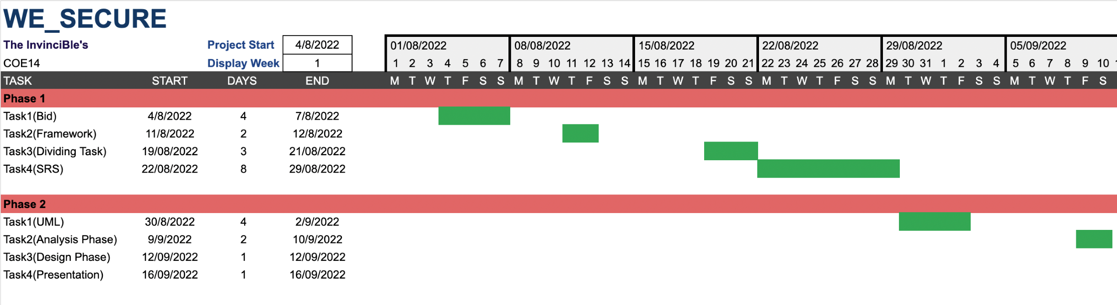**GANTT CHART**

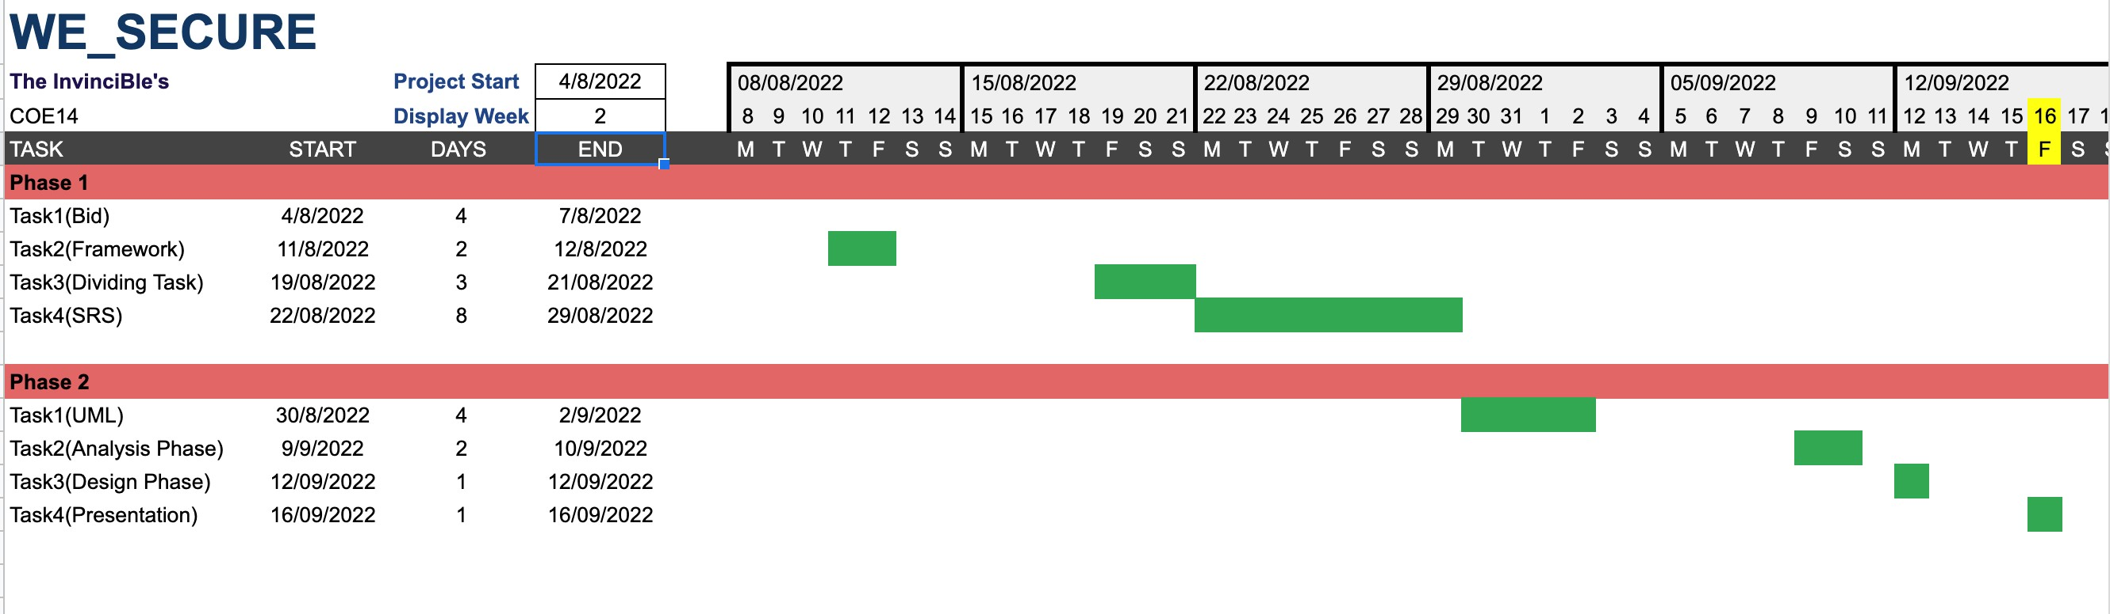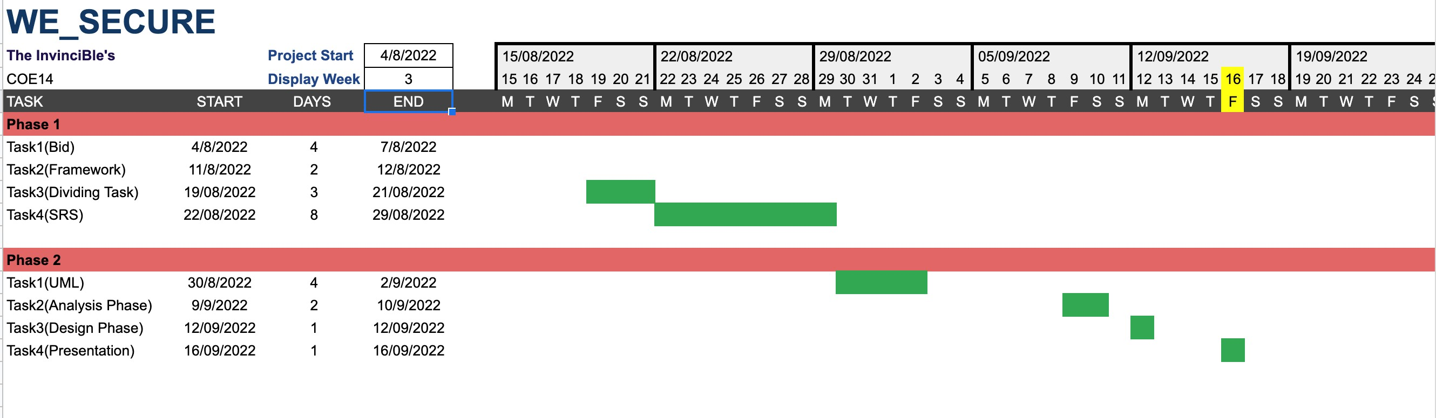

## 2. Analysis Phase

2.1.1 Use Case Template

|  |  |
| --- | --- |
| USE CASE TITLE | VALIDATION |
| ABBREVIATED TITLE | VALIDATION |
| USE CASE ID | 3 |
| ACTORS | AUTHORIZER |
| DESCRIPTION | HERE A PERSON WITH AUTHORIZER PROFILE WILL POST THE ITEM DEFINING ITS TYPE(LOST/FOUND)WHICH ACTS AS THE INPUT AND IS SEND TO THE DATABASE TO VERIFY THE DETAILS |
| PRE CONDITIONS | MEMBER MUST HAVE LOGGED IN AND SHOULD HAVE GENERATED QR/OTP AUTHORIZER MUST HAVE LOGGED IN(IN SESSION) |
| TASK SEQUENCE | AUTHORIZER WILL POST A QUERY REGARDING THE ARTICLE AND ONCE HE/SHE SUBMITS IT , AN INSTANCE WILL BE CREATED WHICH WILL BE DISPLAYED ON THE FEED. |
| POST CONDITIONS | MEMBER IS VERIFIED. CAN PROCEED FURTHER AS PER REQUIREMENTS. AUTHORIZER DIRECTED TO VALIDATION SCREEN FOR SUBSEQUENT OPERATIONS. |

|  |  |
| --- | --- |
| MODIFICATION HISTORY | DATE |
| AUTHOR | VANSHAJ CHAYAN KARAN |
| EXCEPTIONAL FLOW | SUBMISSION OF DETAILS FAILS TO WORK PROPERLY |
| ALTERNATE FLOW | MEMBER DETAILS NOT PRESENT HENCE VALIDATION FAILS |

**USE CASE SCENARIO**

1. (AA)- Authorizer/Authenticator logins using his unique id.  
2. (SR)- System checks the identification provided and logins the authorizer. 3. (AA)-Authorizer clicks on “Verify identity”.  
4. (SA)- System opens Identity Verification Portal.  
5. (AA)- Authorizer scans the person’s QR or takes his otp .  
6. (SA)- System opens the details of the person stored in the database.  
7. (AA)- Authorizer approves the entry/exit of the person.  
8. (SR)- System updates the database appropriately.  
9. (AA)- Authorizer logs out and ends the session.

### 2.1.1 Use-Case Diagram

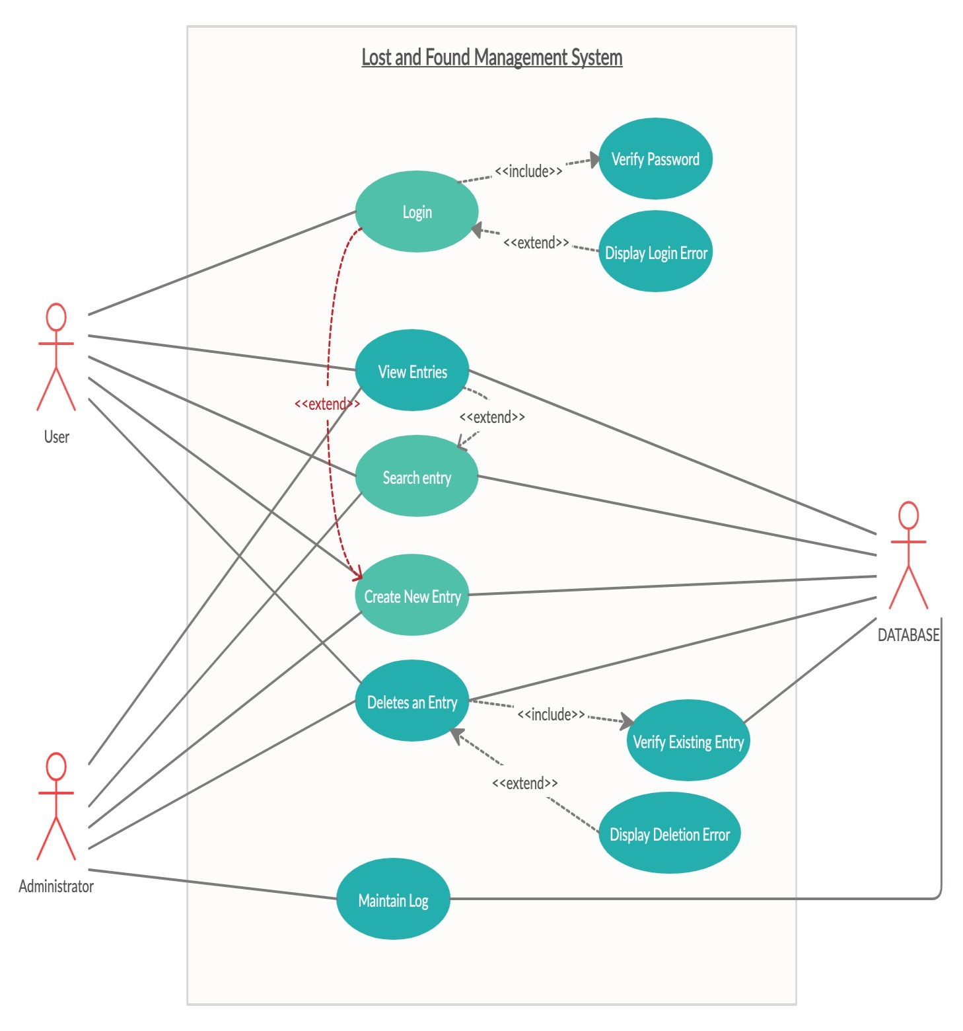

### 2.2 Swimlane Diagrams

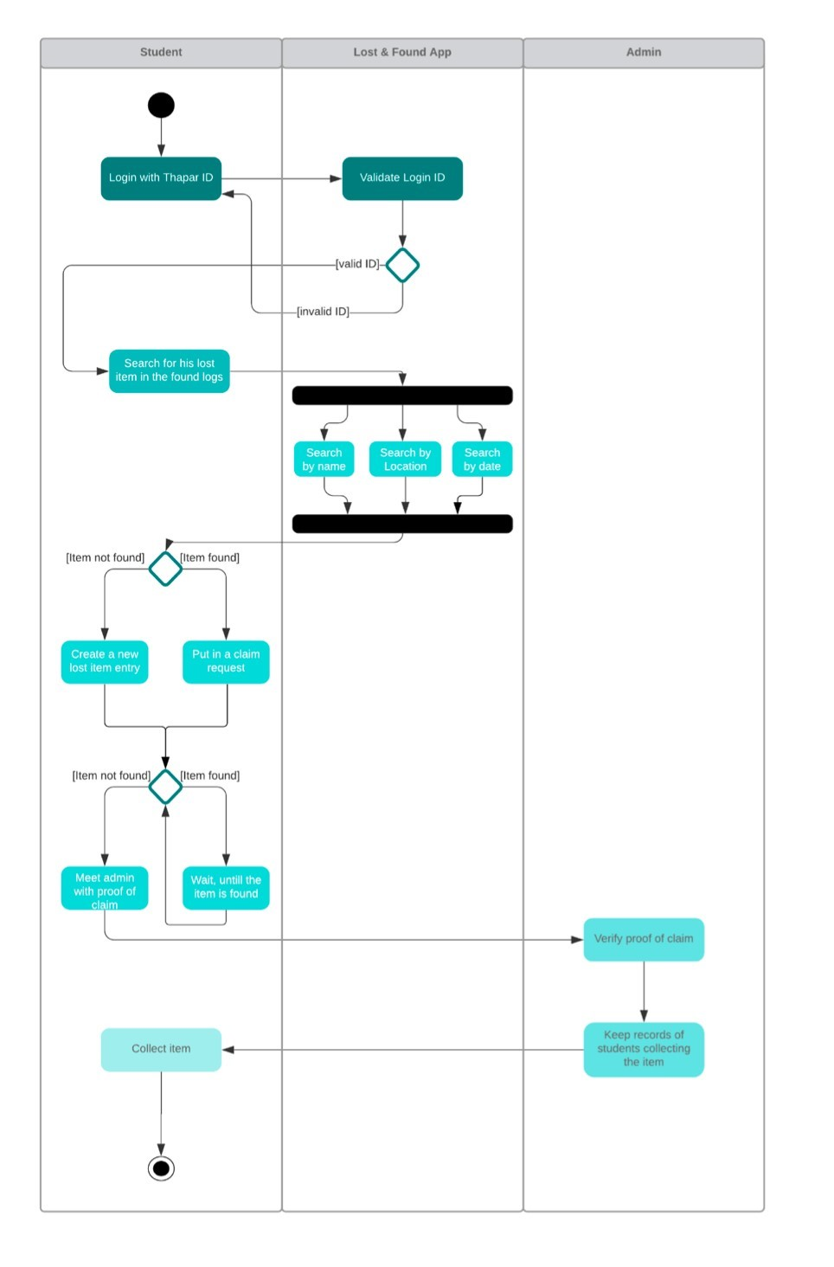

#### 2.3 Data Flow Diagram

##### 2.3.1 DFD Level 0

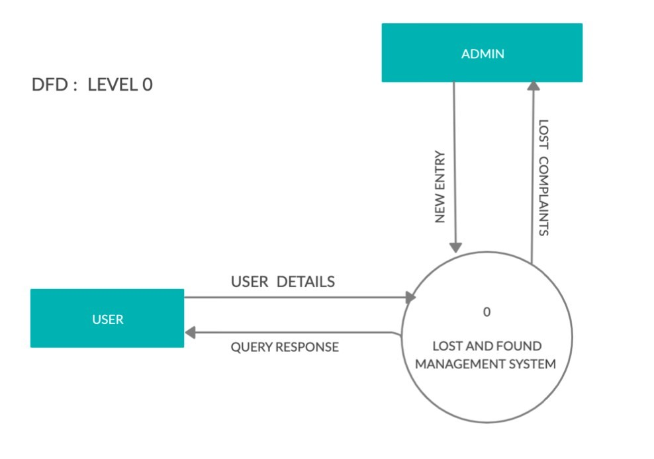

##### 2.3.2 DFD Level 1

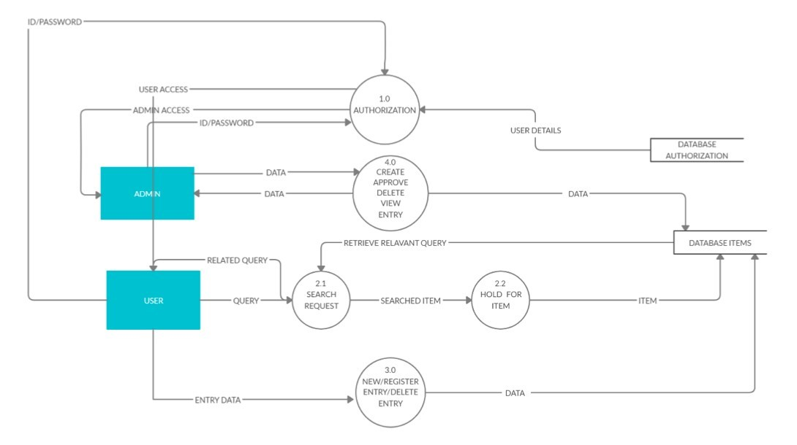

##### 2.3.3 DFD Level 2

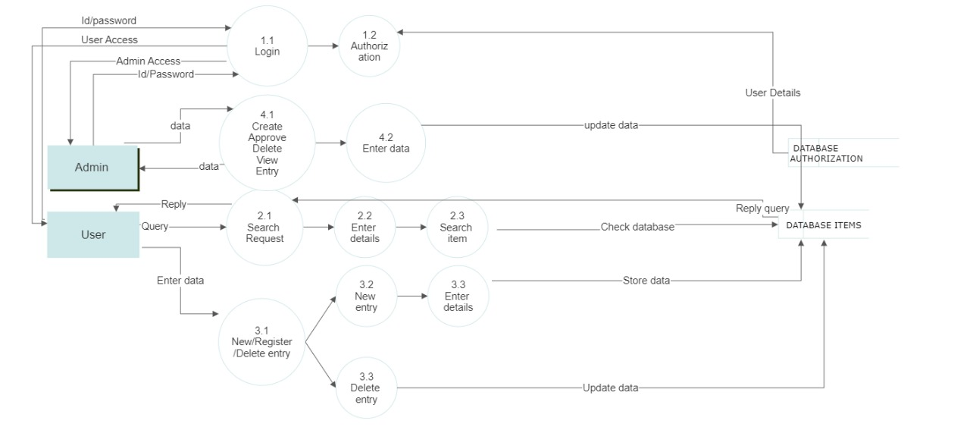

# Software Requirements Specification Document

Version 1.0

# We_Secure

## Submitted By: The Invincible’s







|  |  |
| --- | --- |
| Roll Number | Name |
| 102003346 | Vanshaj Singla |
| 102003347 | Chayan Sinha |
| 102003355 | Karan Singla |

### 1. Introduction

This section gives a scope description and overview of everything included in this SRS document. Also, the purpose for this document is described and a list of abbreviations and definitions is provided.

#### 1.1. Purpose

The purpose of this document is to give a detailed description of the requirements for the “CampusCare” software. It will illustrate the purpose and complete declaration for the development of system. It will also explain system constraints, interface and interactions with other external applications. This document is primarily intended to be proposed to a customer for its approval and a reference for developing the first version of the system for the development team.

#### 1.2. Scope

The “WE_SECURE” is a web application which helps people to find their lost articles by registering their query on our website. Once the article is found , it will be notifying the people on the platform and informing the staff of the concerned area. After the article is discovered, it will further be verified to the concerned person.

A Real-Time Campus Navigator will also be implemented which will navigate the freshers around the campus.

This information will act as the bases for the search results displayed to the user. An administrator also uses the web-portal in order to administer the system and keep the information accurate. Furthermore, the software needs both Internet and GPS connection to fetch and display results. All system information is maintained in a database, which is located on a web-server.

Furthermore, our website can also be extended for the welfare of the animal . If an animal is found injured or not in a conscious state, the user can post a query on the web portal stating the location of the injured subject.

#### 1.3. Definitions, abbreviations and acronyms

**Definitions**

Table 1 gives explanation of the most commonly used terms in this SRS document.

### S No. Term Definition

1. Interface When referring to software,

an interface is a program that allows a user to interact computers in person or over a network. An interface may also refer to controls used in a program that allow the user to interact with the program.

1. Server A server is a computer

program or device that provides a service to another computer program and its user, also known as the client.

**Abbreviations**

Table 2 gives explanation of the most commonly used mnemonics in this SRS document.

|  |  |  |
| --- | --- | --- |
| S No. | Mnemonic | Full form |
| 1 | HTML | Hypertext Markup Language |
| 2 | CSS | Cascading Style Sheets |
| 3 | IEEE | Institute of Electrical and Electronics Engineers |
| 4 | UI | User Interface |
| 5 | DB | Database |
| 6 | ID | Identity Document |
| 7 | OS | Operating System |
| 8 | ER Diagram | Entity Relationship Diagram |

#### 1.4. References

1. <https://lostandfoundnetworks.com/>
2. <https://techvidvan.com/tutorials/lost-and-found-android-app-project/>
3. [https://www.studocu.com/row/document/comsats-university-islamabad/topics-incomputer-science-ii/se46-lost-and-found-management-system/20837857](https://www.studocu.com/row/document/comsats-university-islamabad/topics-in-computer-science-ii/se46-lost-and-found-management-system/20837857)

#### 1.5. Overview

The remaining sections of this document have been written as an attempt to provide a comprehensive guide to users of this product so that they can use it efficiently. Section 2 of this document is a detailed description of the overall product: its perspective, functions, user characteristics as well as general constraints, assumptions and dependencies. Section 3 discusses the various functional, non-functional and external requirements for the product to run successfully. Section 4 enlists the change history of this document and Section 5 contains the details of the document approver.

#### 2. Overall Description

##### 2.1 Product Perspective

This ‘Campus Care Web App’ requires a web-based system, that is., the website. The website would be an interactive space with various functionalities where students can create their accounts, set up passwords. **2.2 Product Functions**

The product should be able to perform the following operations:

1. It must be able to authenticate an old user already registered on the website with the help of the password set up by them and at the same time must also enable the first-time users to register on the website and set up their account.
2. It must enable the students to enter the location and description of lost article.
3. It must display the user a list of lost and found items.
4. It must be able send a message to the concerned staff working in that area.

##### 2.3 User Characteristics

The main purpose behind designing this is to provide a hassle-free experience to all its users (primarily students).

The following two classes are expected to be using this product:

* **User:** User will directly interact with the user interface and use the functionalities of the product. The user will not have access to the data of the users and also no view or

access to the database. It will have no control over the general functionalities as well.

* **Admin :** Admin controls the basic functionalities as well as plans the way users will see the interface. Admin can view the data of the users for improvement.

##### 2.4. General Constraints, Assumptions and Dependencies

• Students must enter their correct e-mail ids and passwords when registering to perform actions on the website. The mail ids entered must be domain-specific, that is., associated with a specific mail server (here institute(s)). E.g., abc@thapar.edu.

* The system is only compatible with devices running Windows 32-bit & 64-bit computer systems with active Internet browsing capabilities and an Internet connection. The system does not work well on devices currently running Mac OS, Android OS, and iOS.
* Presently, the website can handle up to 1000 user visits at a time. More students simultaneously logging in can potentially result in a server crash, and students may face issues logging in.

##### 2.5 Apportioning of requirements

The Campus Care WebApp is to be implemented in the following two phases:

1. **Pilot Phase**: In this phase, the system will be implemented on small area of CSED block.

1. **Institute wide deployment:** Following the successful completion of the pilot phase, we will deploy the system across the university.

#### 3. Specific Requirements

##### 3.1 External Interface Requirements

The following are the external interface requirements:

* Hardware Required: The product requires the use of bar code scanners and ID cards to be issued to all students. These id cards contain unique bar codes for each enrolment number.
* Supported Device Types: The software is developed for Windows 32-bit and Windows 64-bit computer systems. The subsequent versions of the product would support more device types.
* The product requires a simple keypad for taking user input (login details).
* The font size and style make the text legible and easy to understand.
* There are no flashy animations or photosensitive images.
* The navigation bar at the top helps the users to move between pages quickly.

##### 3.2 Functional Requirements

Functional requirement are the functions or features that must be included in any system to satisfy the business needs and be acceptable to the users. Based on this, the functional requirements that the system must require are as follows:

1.The system should be able to accept the data of the concerned user.

2.The system A web application which will assist the people to find their lost articles by notifying the people on the platform.

3.Once the request is registered, it will be landed on our database

4.A Real Time Map will act as a navigator for the freshers.

5. Animal Welfare can also be implemented in the future prospectus

##### 3.3 Non-Functional Requirements

Non-functional requirement is a description of features, characteristics and attribute of the system as well as any constraints that may limit the boundaries of the proposed system. The non- functional requirements are essentially based on the performance, information, economy, control and security efficiency and services. Based on these the non-functional requirements are as follows:

* **Performance:** Each page of the website must load within 4 seconds.
* **Availability:** It must be accessible to all the students of the institute 24*7.
* **Security:** The website will not grant access until the student sets a strong password.
* **Reusability:** The website must reuse the header and footer, that is, on every page of the website, the user sees the same options in header and footer. Moreover, the login feature used in this website can also be used by the developers on other websites and web pages.
* **Modifiability:** The website must be designed in such a way that it should be easy to make changes as it is scaled onto successive versions. No pages of the website would contain too many images or animations. Content should be placed such that it is easy for users to read, interpret and remember.
* **Usability:** No pages of the website would contain too many images or animations.

Content should be placed such that it is easy for users to read, interpret and remember.

* **Scalability:** The system must be scalable enough to support 1000 visits at the same time while maintaining optimal performance.

## 3.Design Phase

### 3.1 Class Diagram

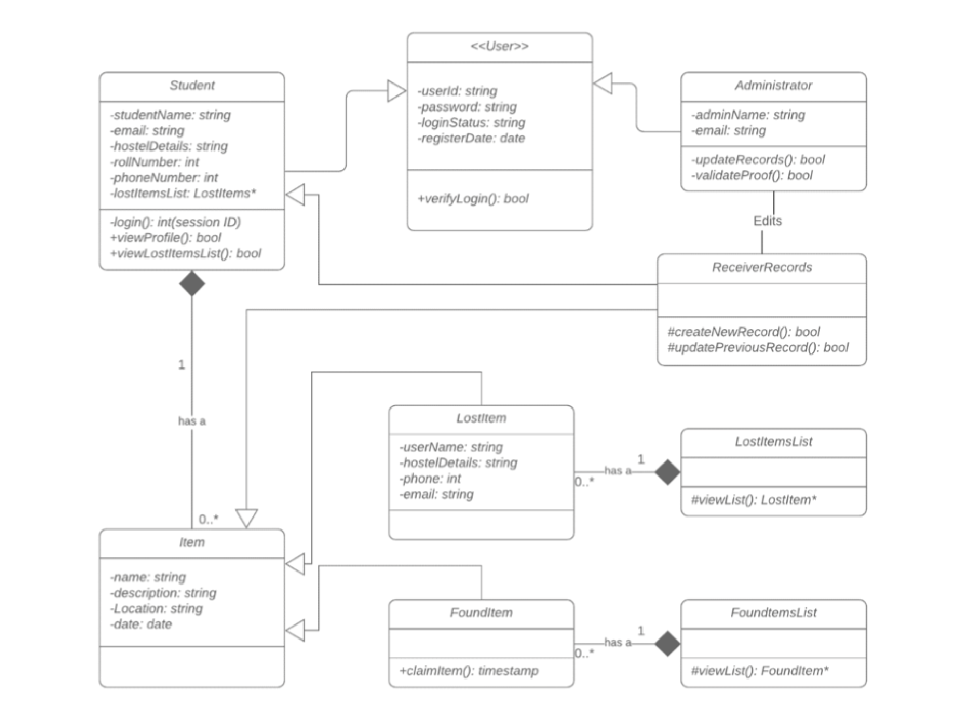

### 3.2 Sequence Diagram

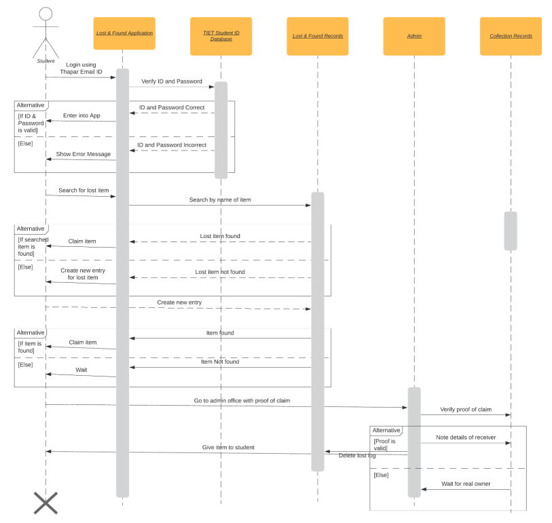

### 3.3 Collaboration Diagram

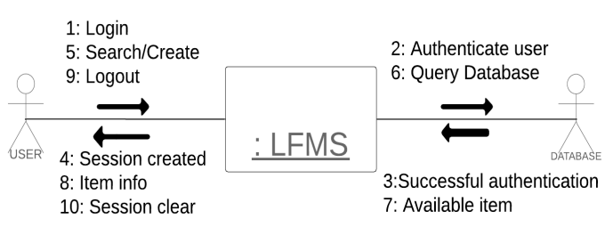

### 3.4 ER Diagram

WE_SECURE CAMPUS CARE

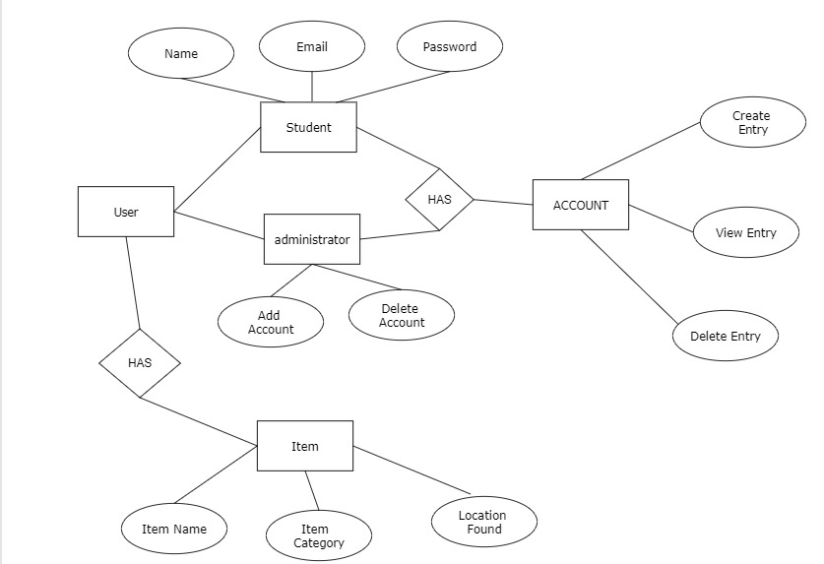

### 3.5 State Diagram

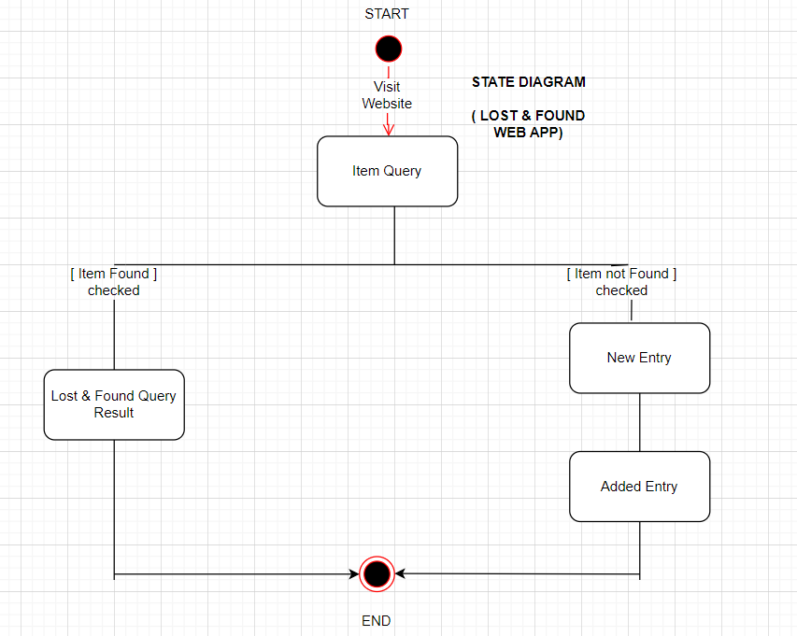

### 4. Implementation

### 4.1 Component Diagram

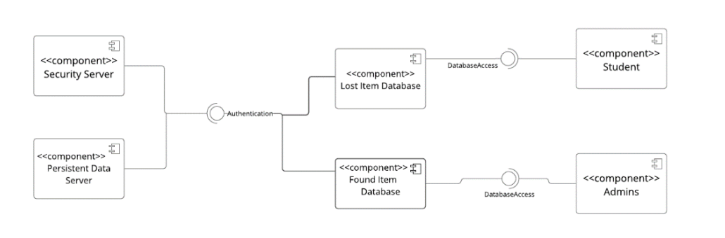

### 4.2 Deployment Diagram

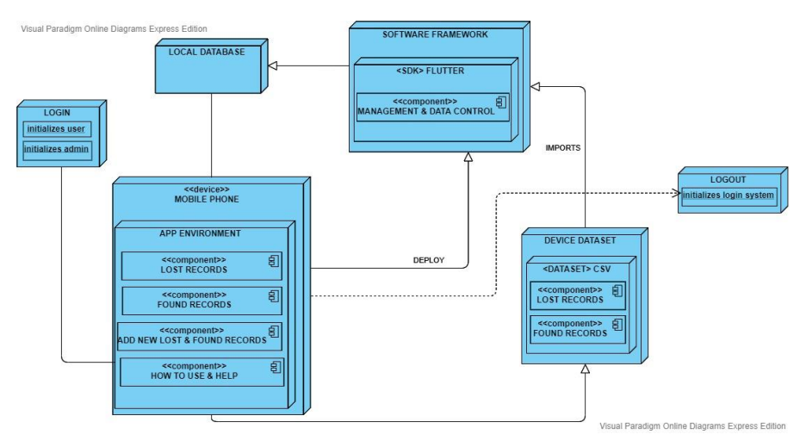

### 4.3 Screenshots of Working Project

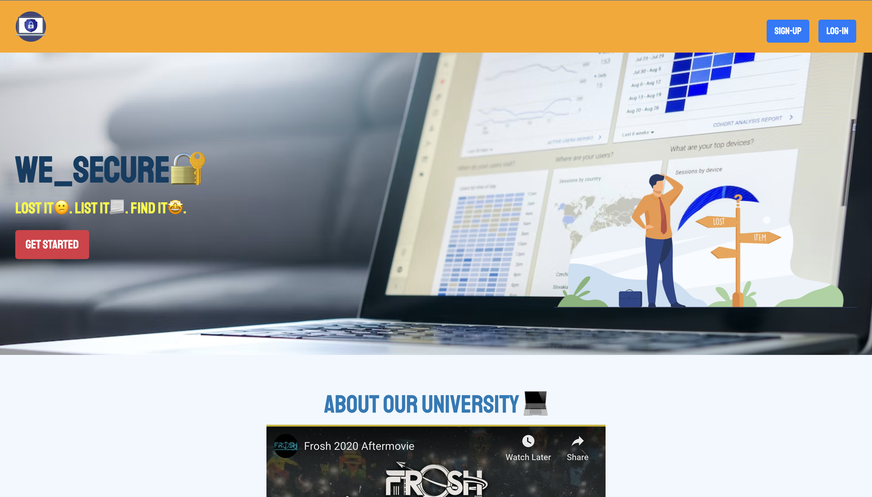

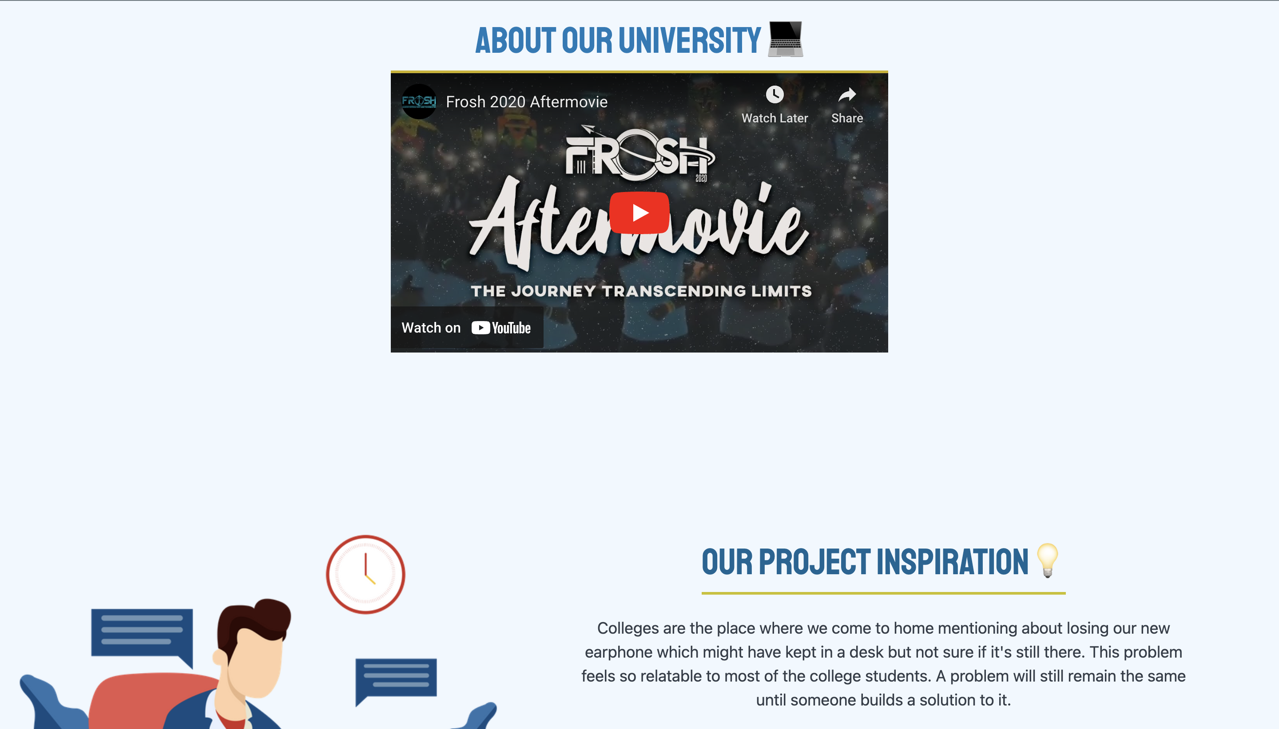

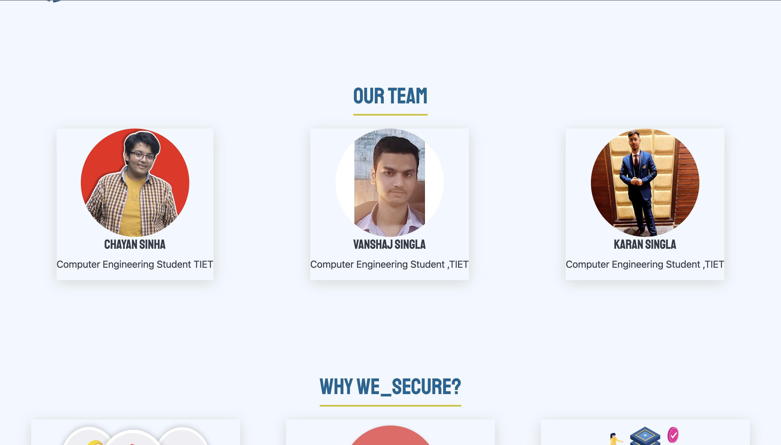

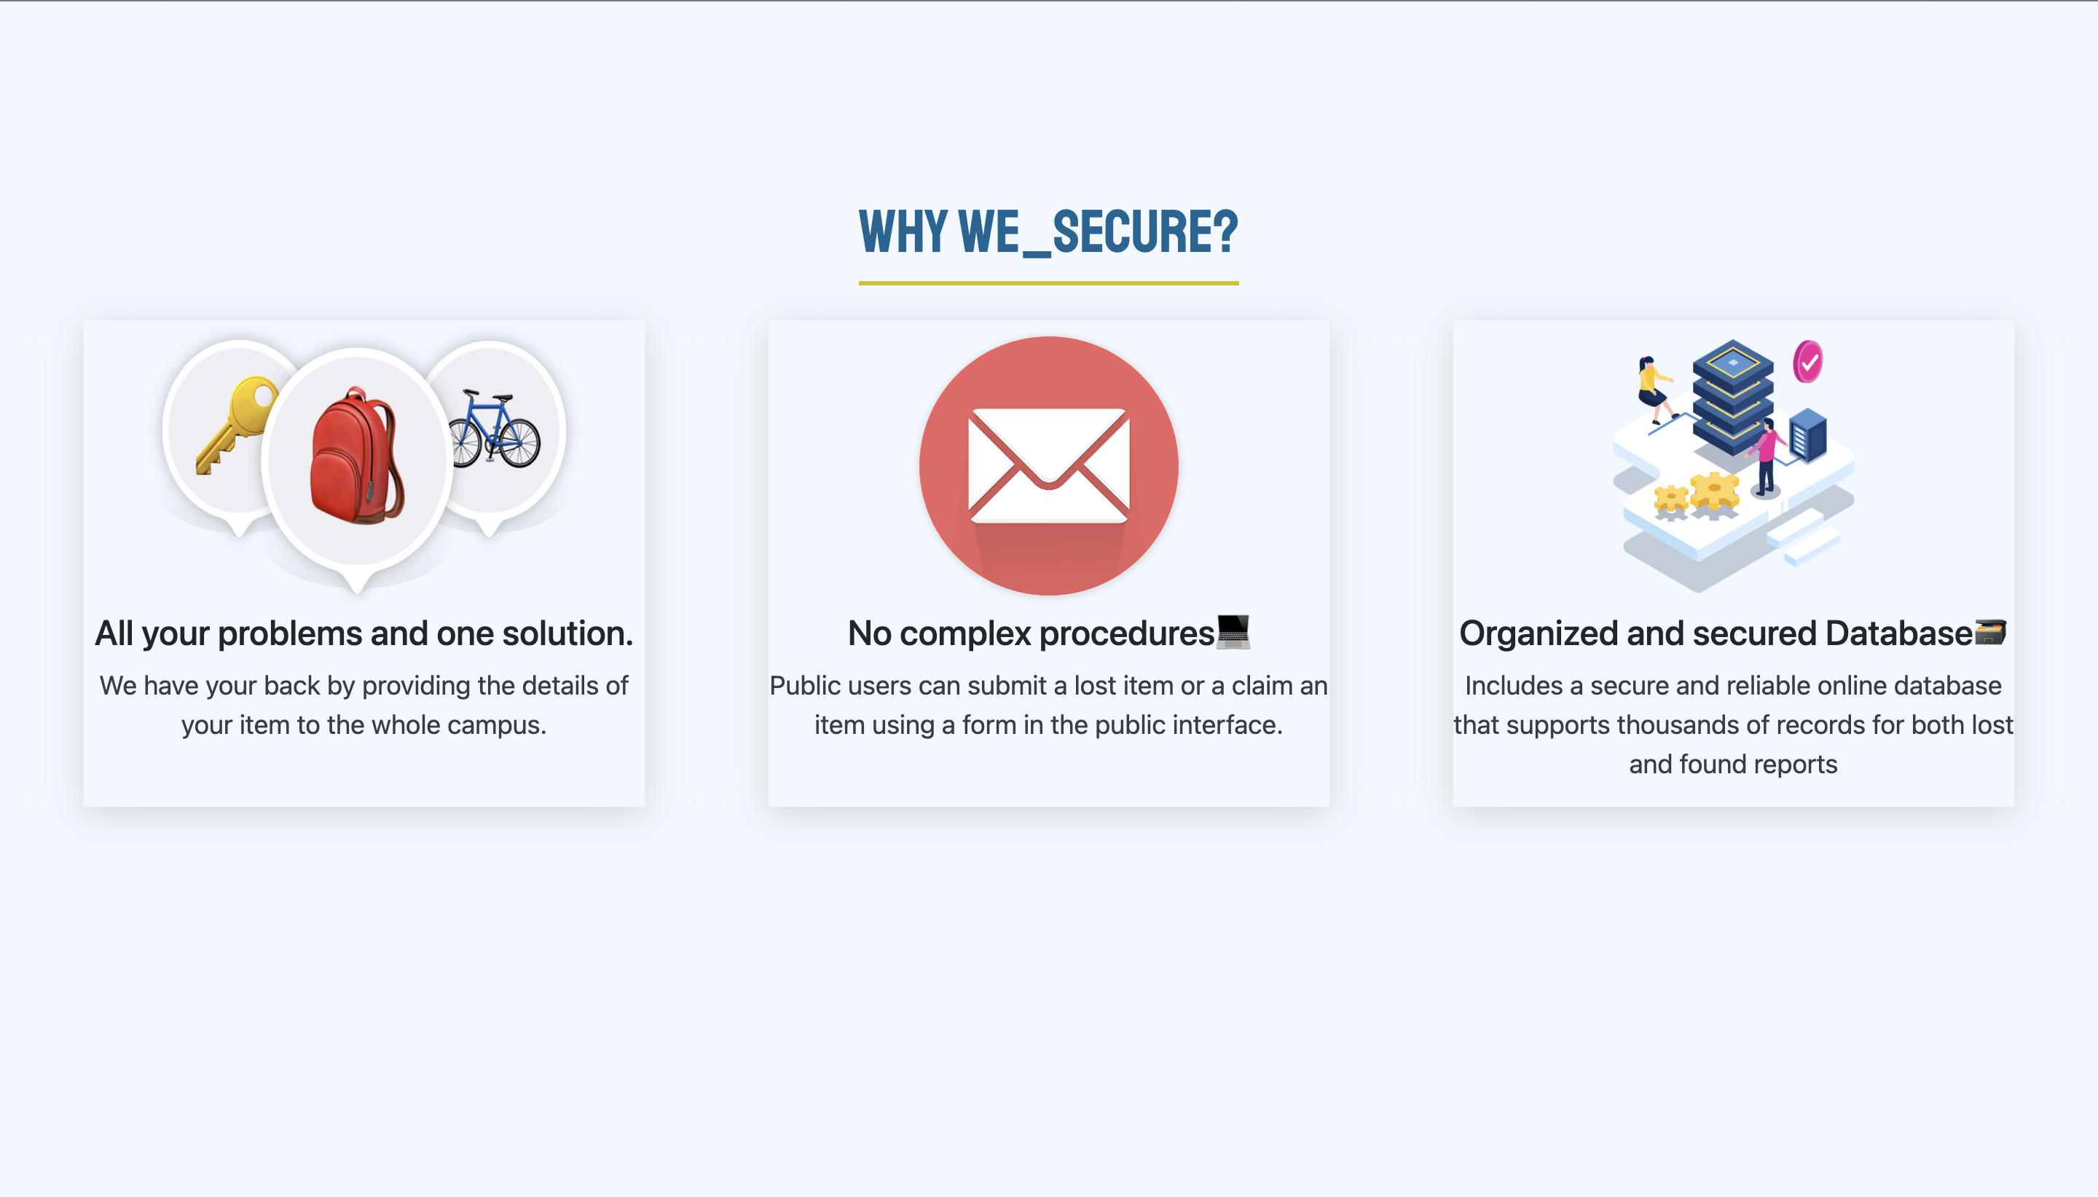

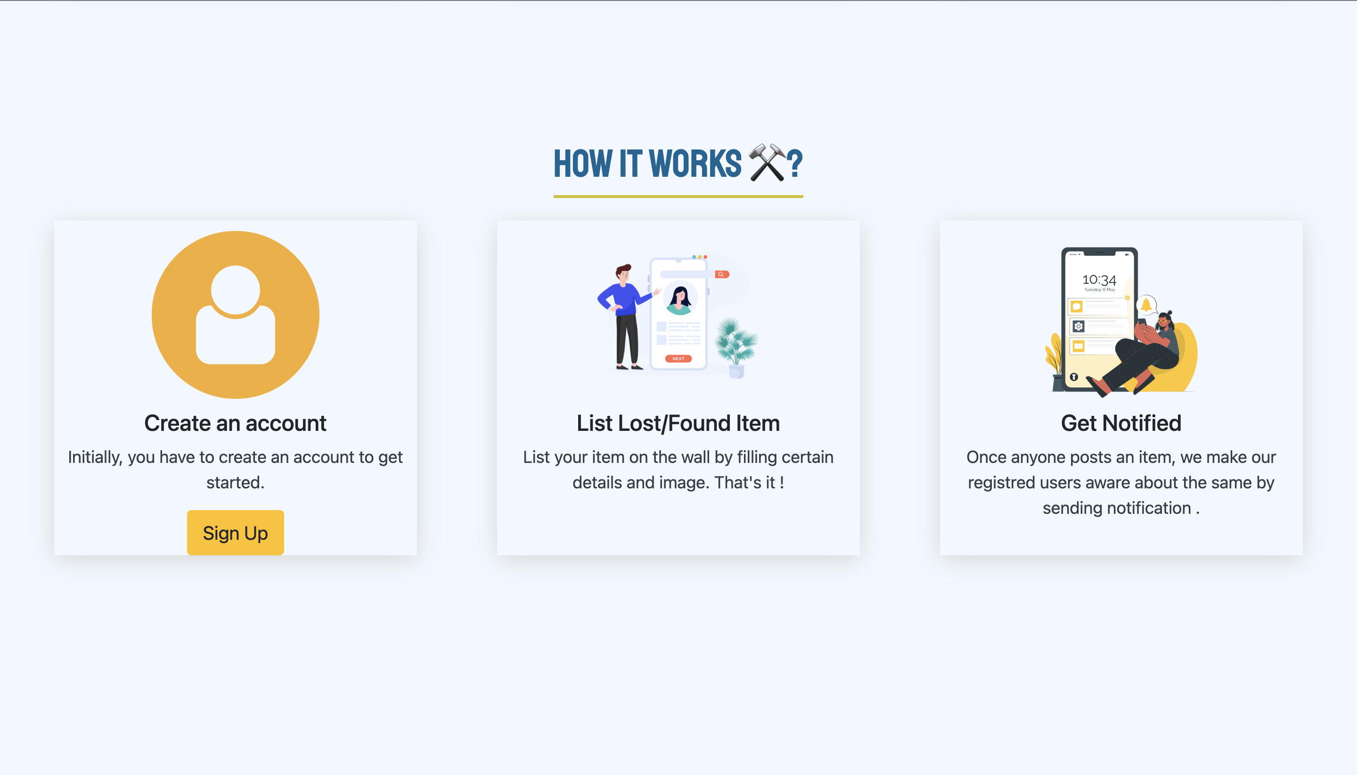

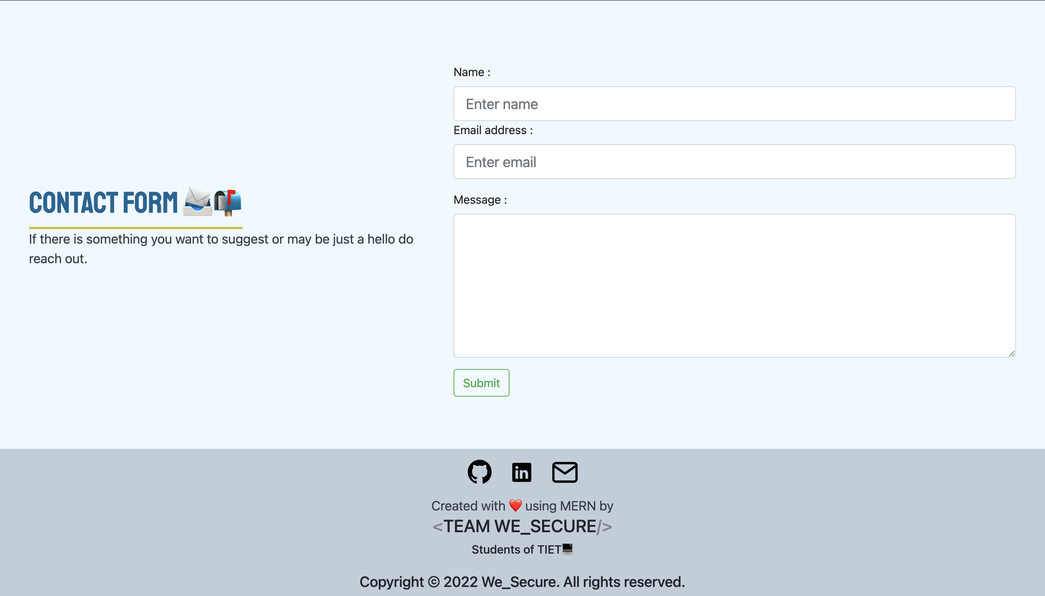

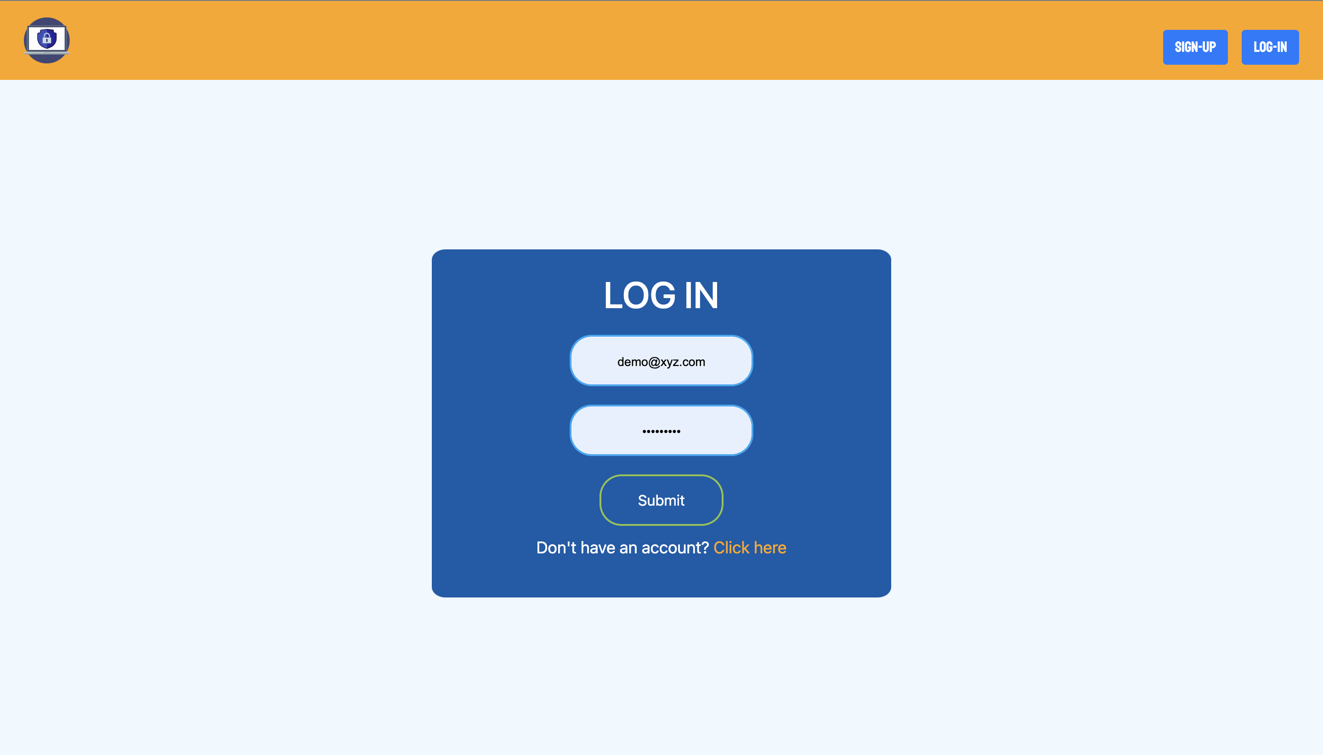

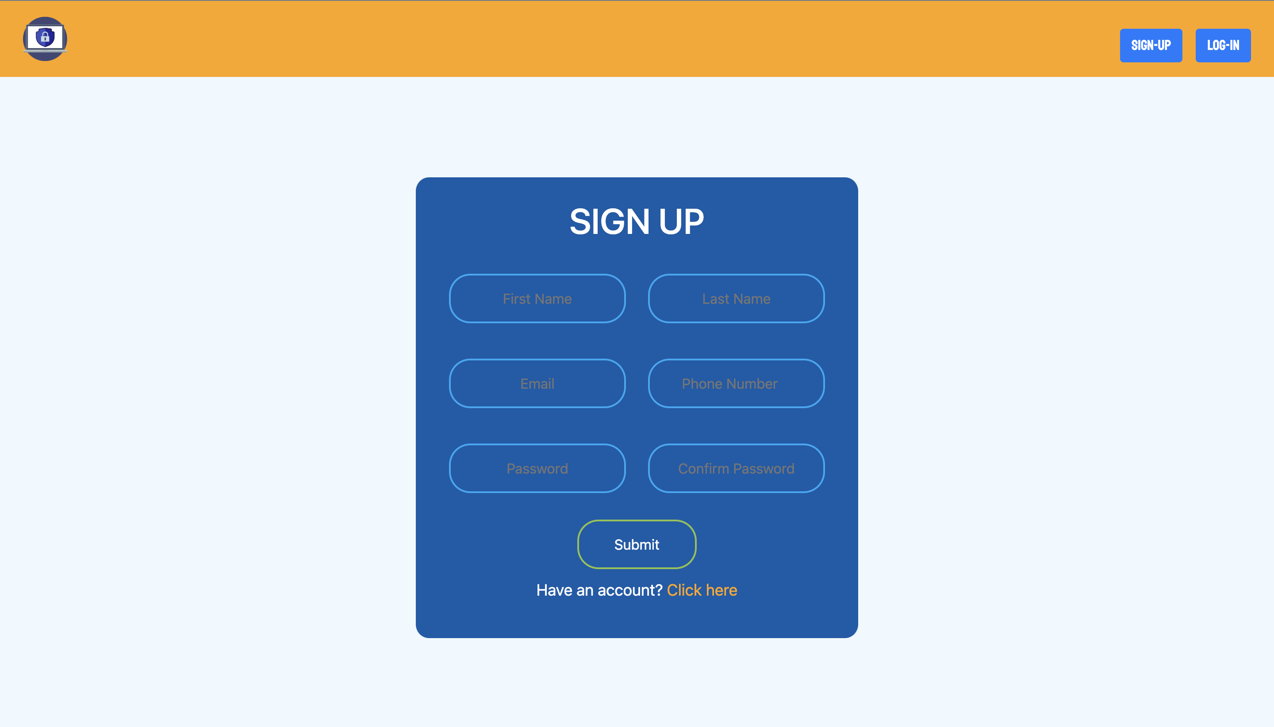

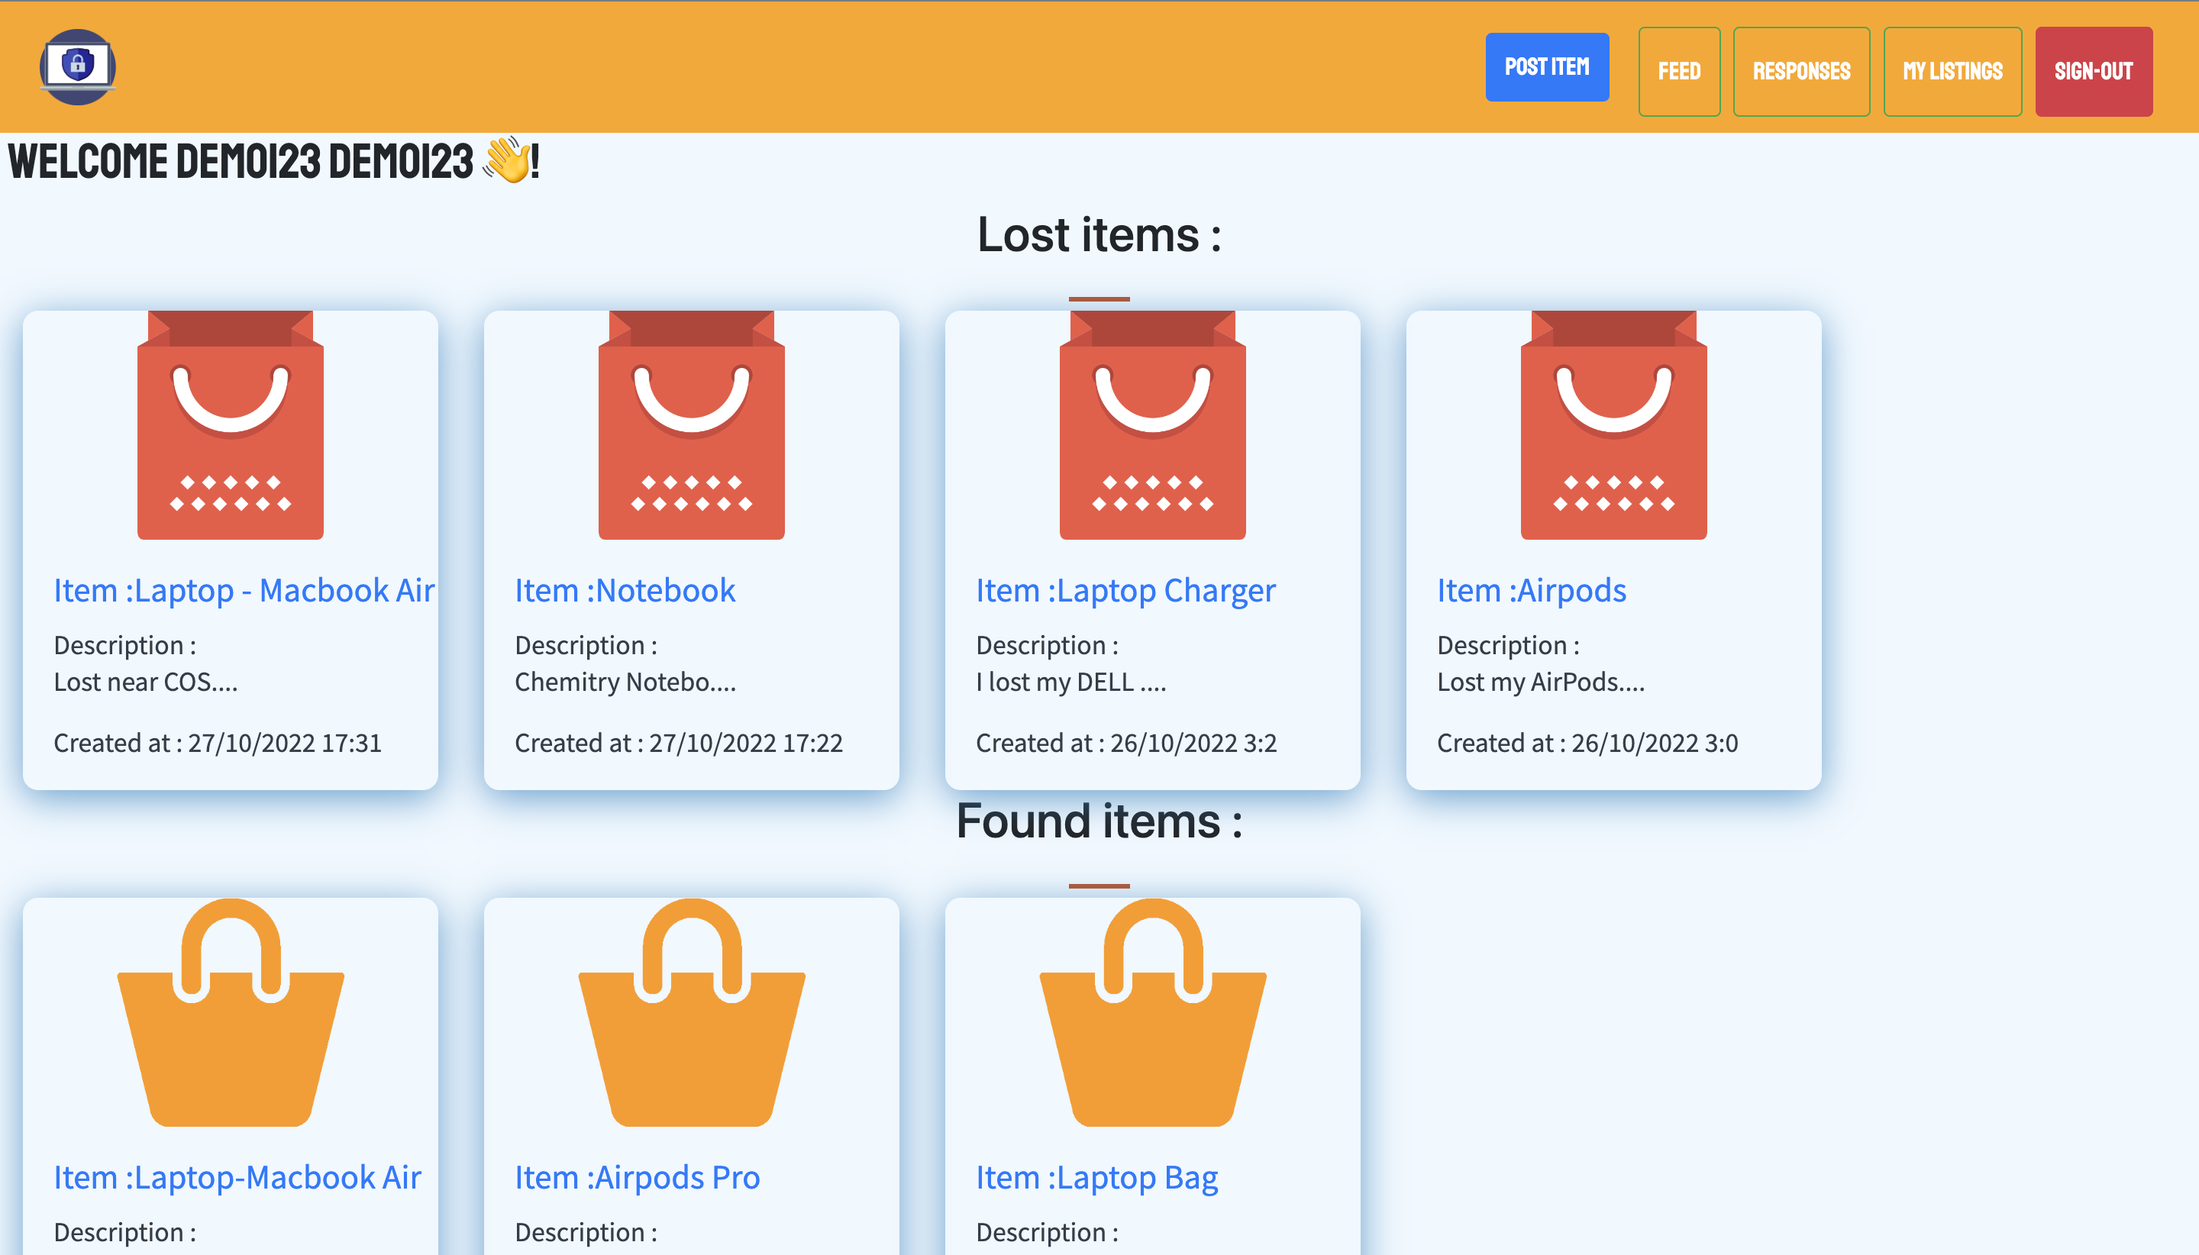

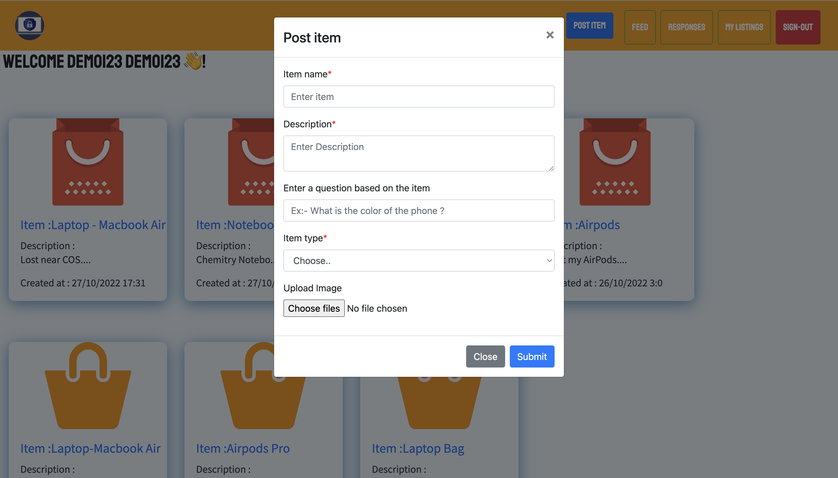

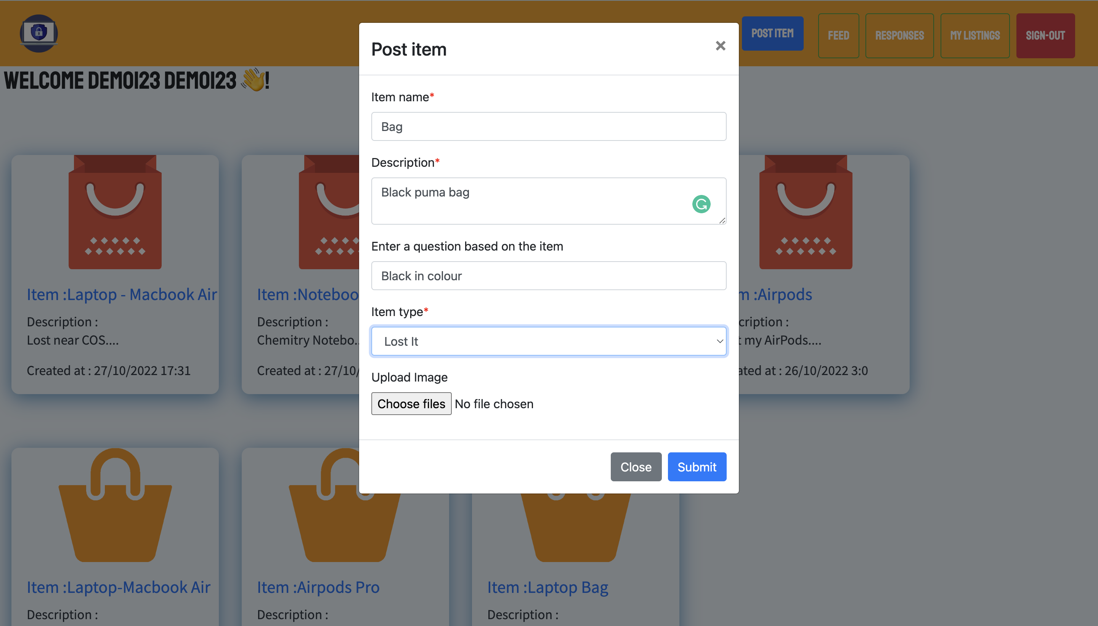

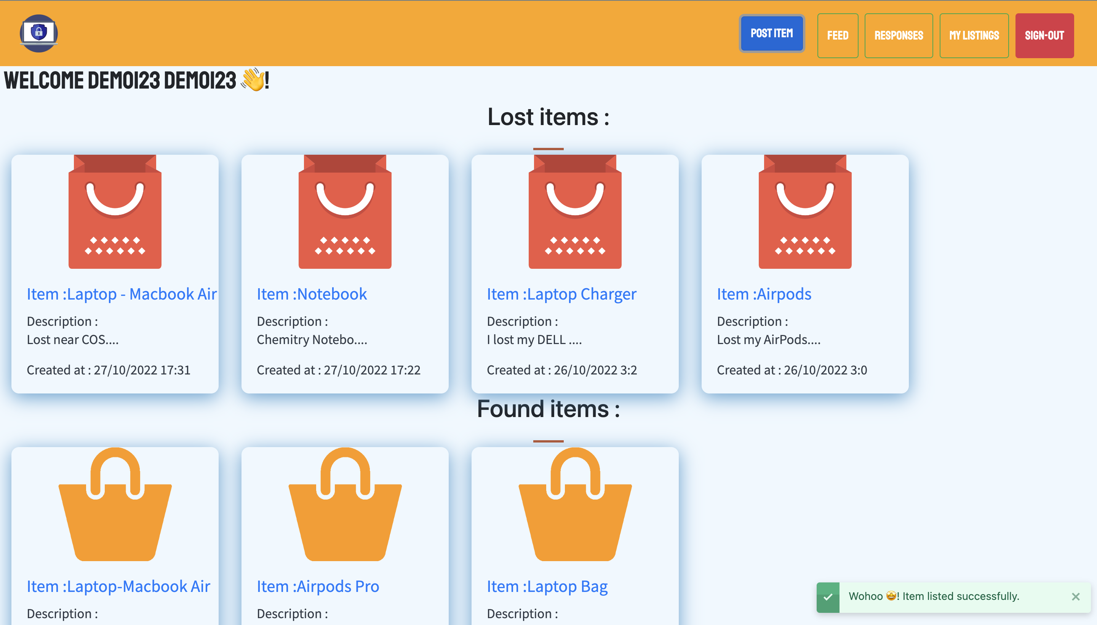

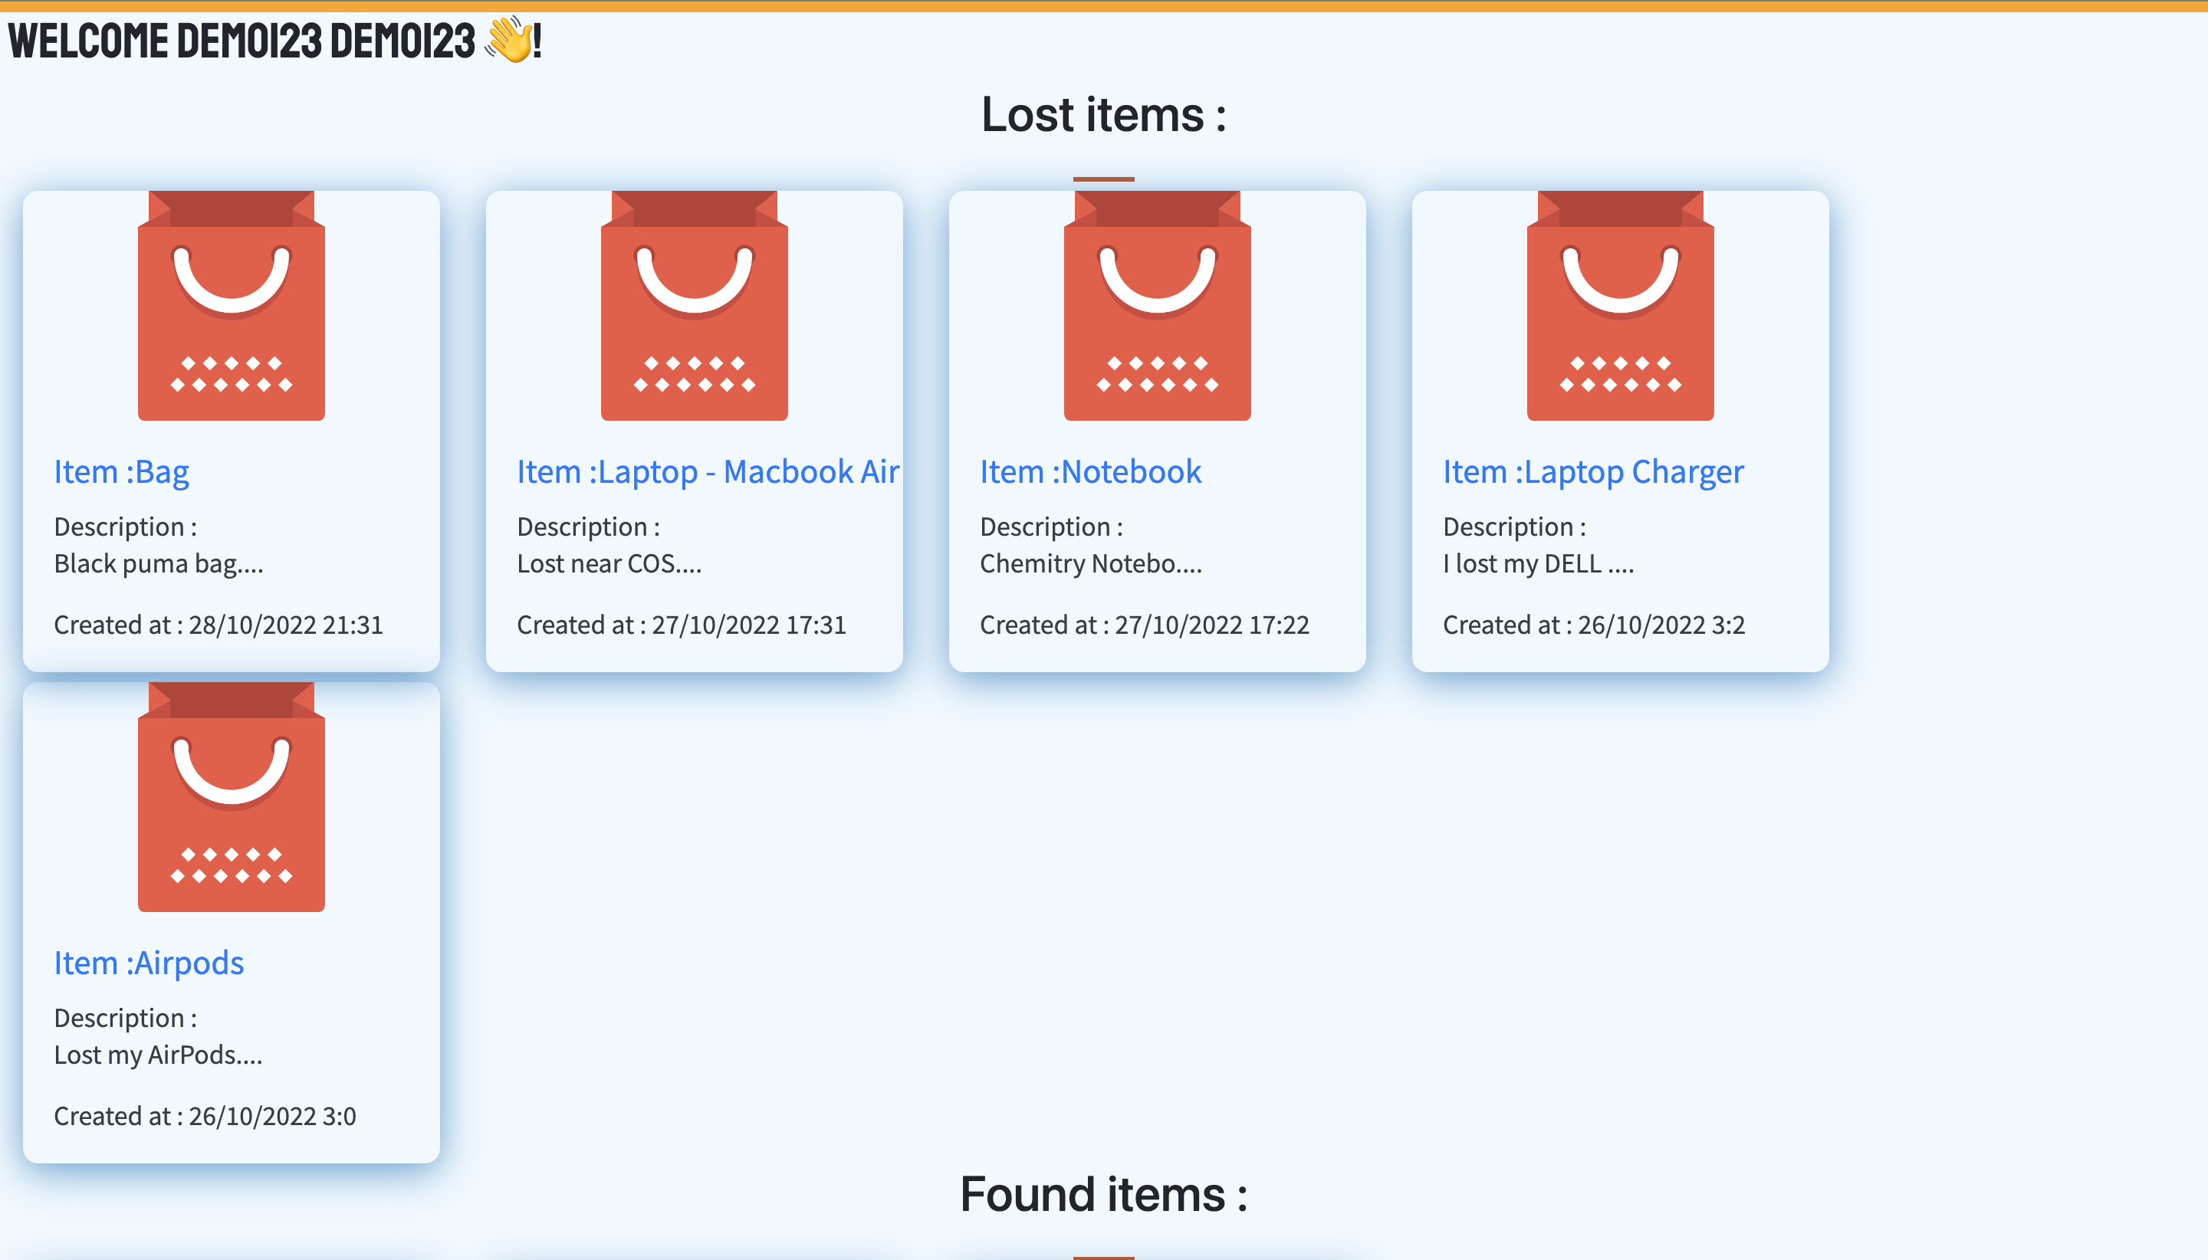

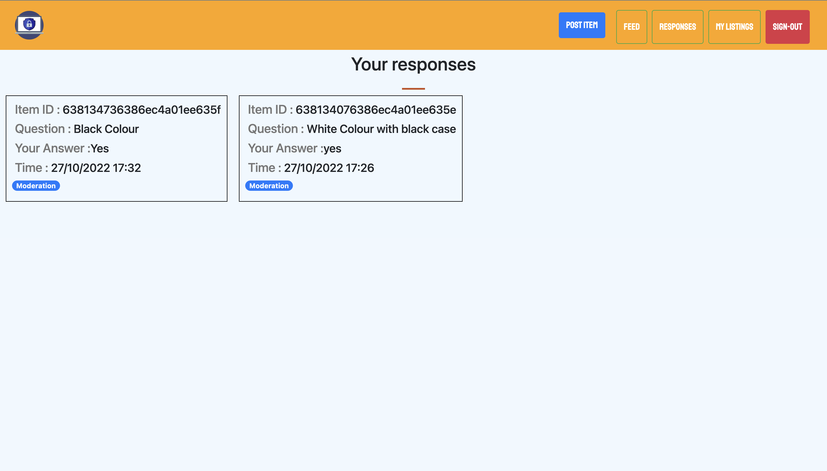

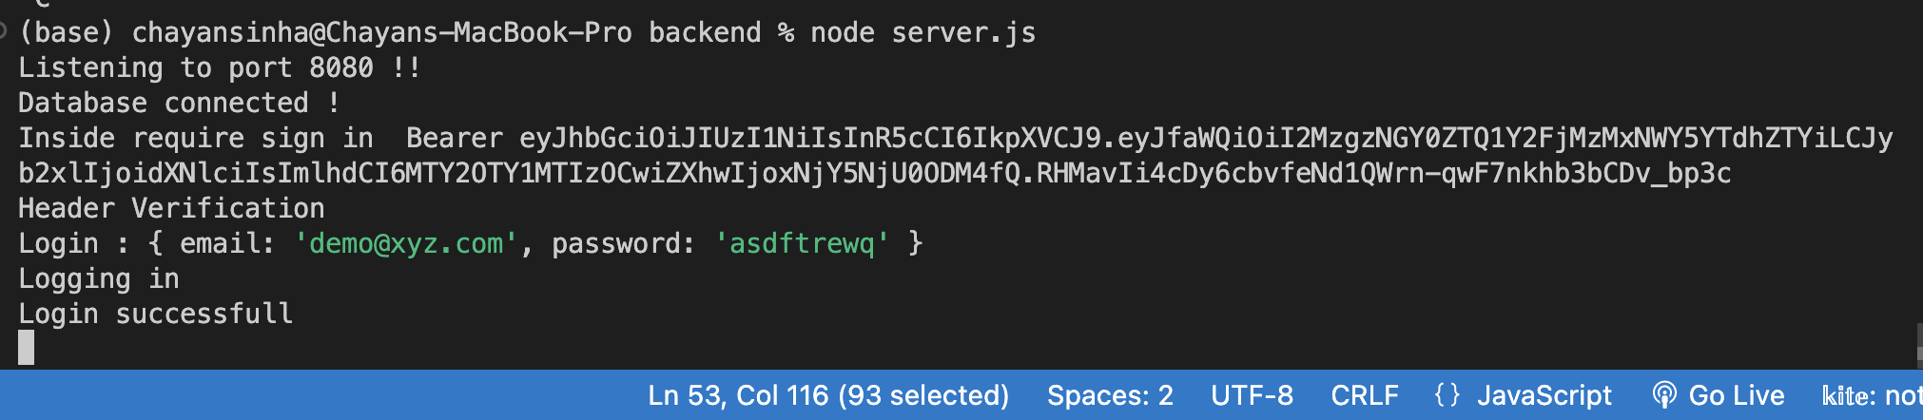

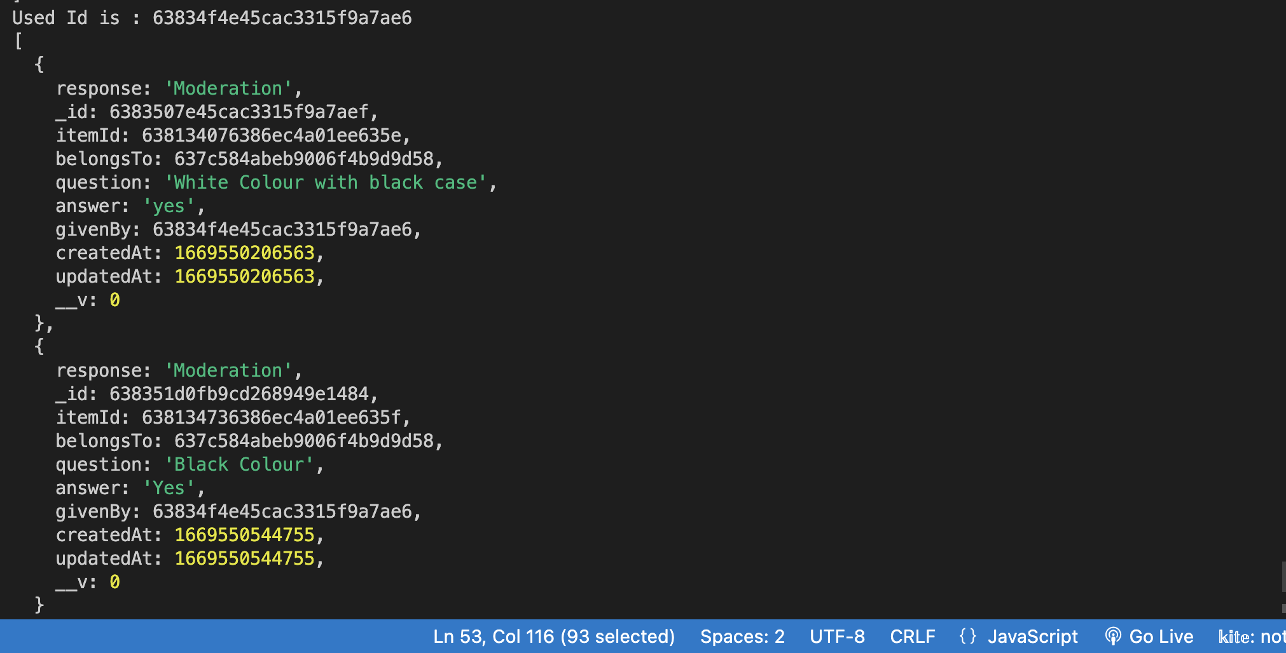

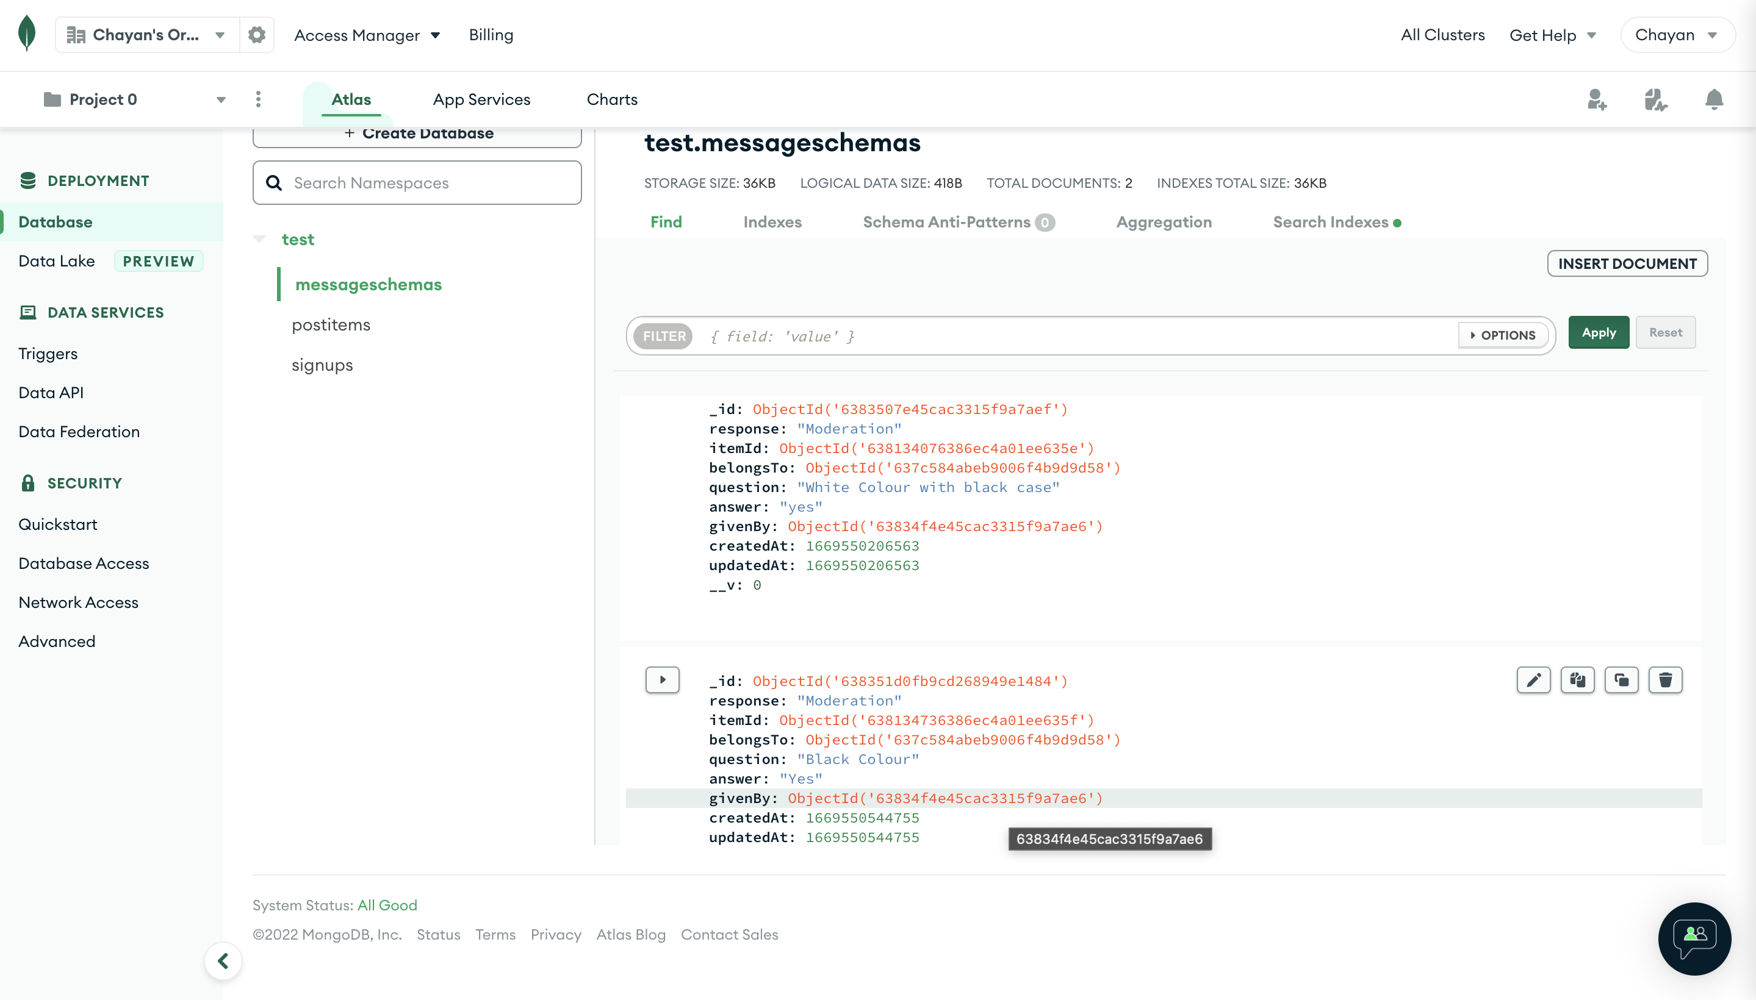

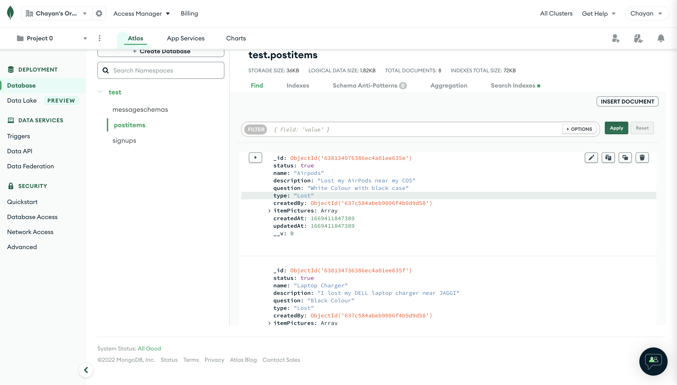

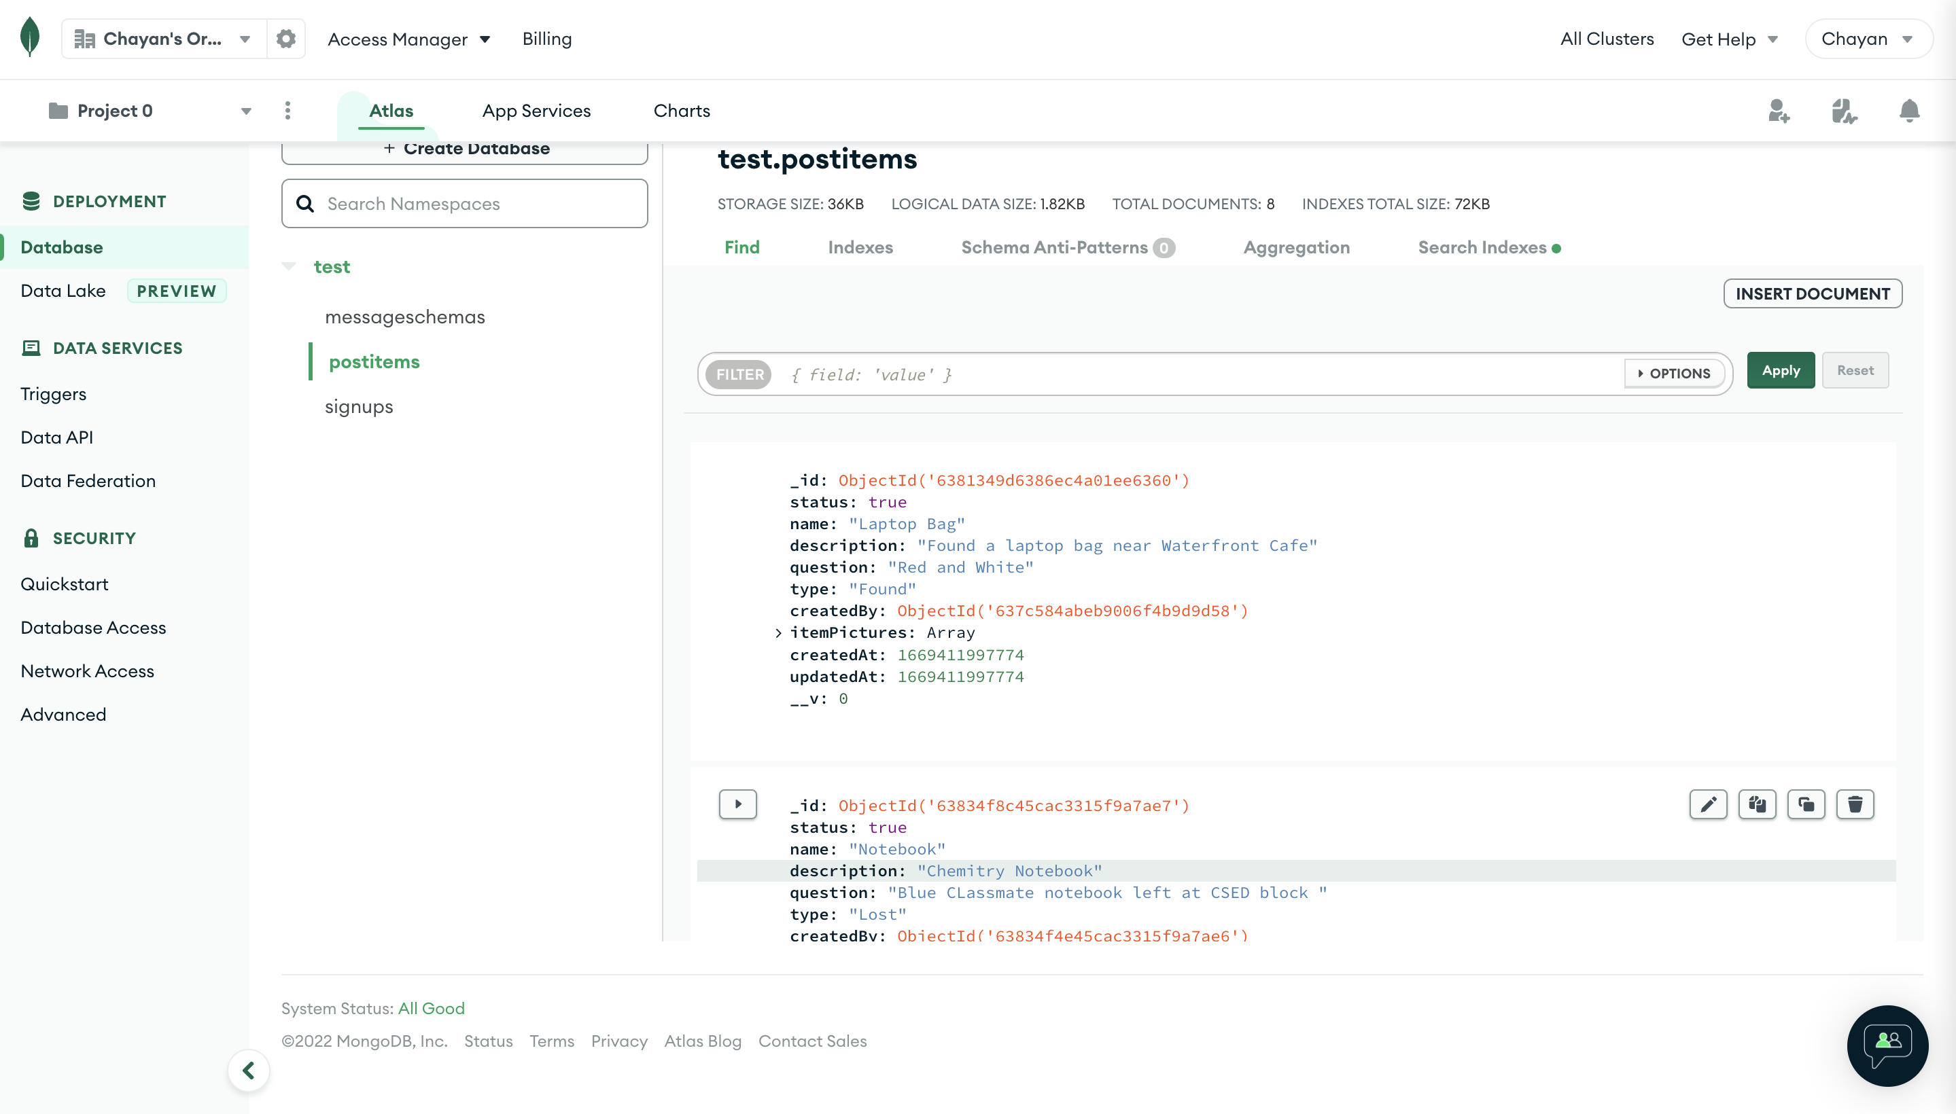

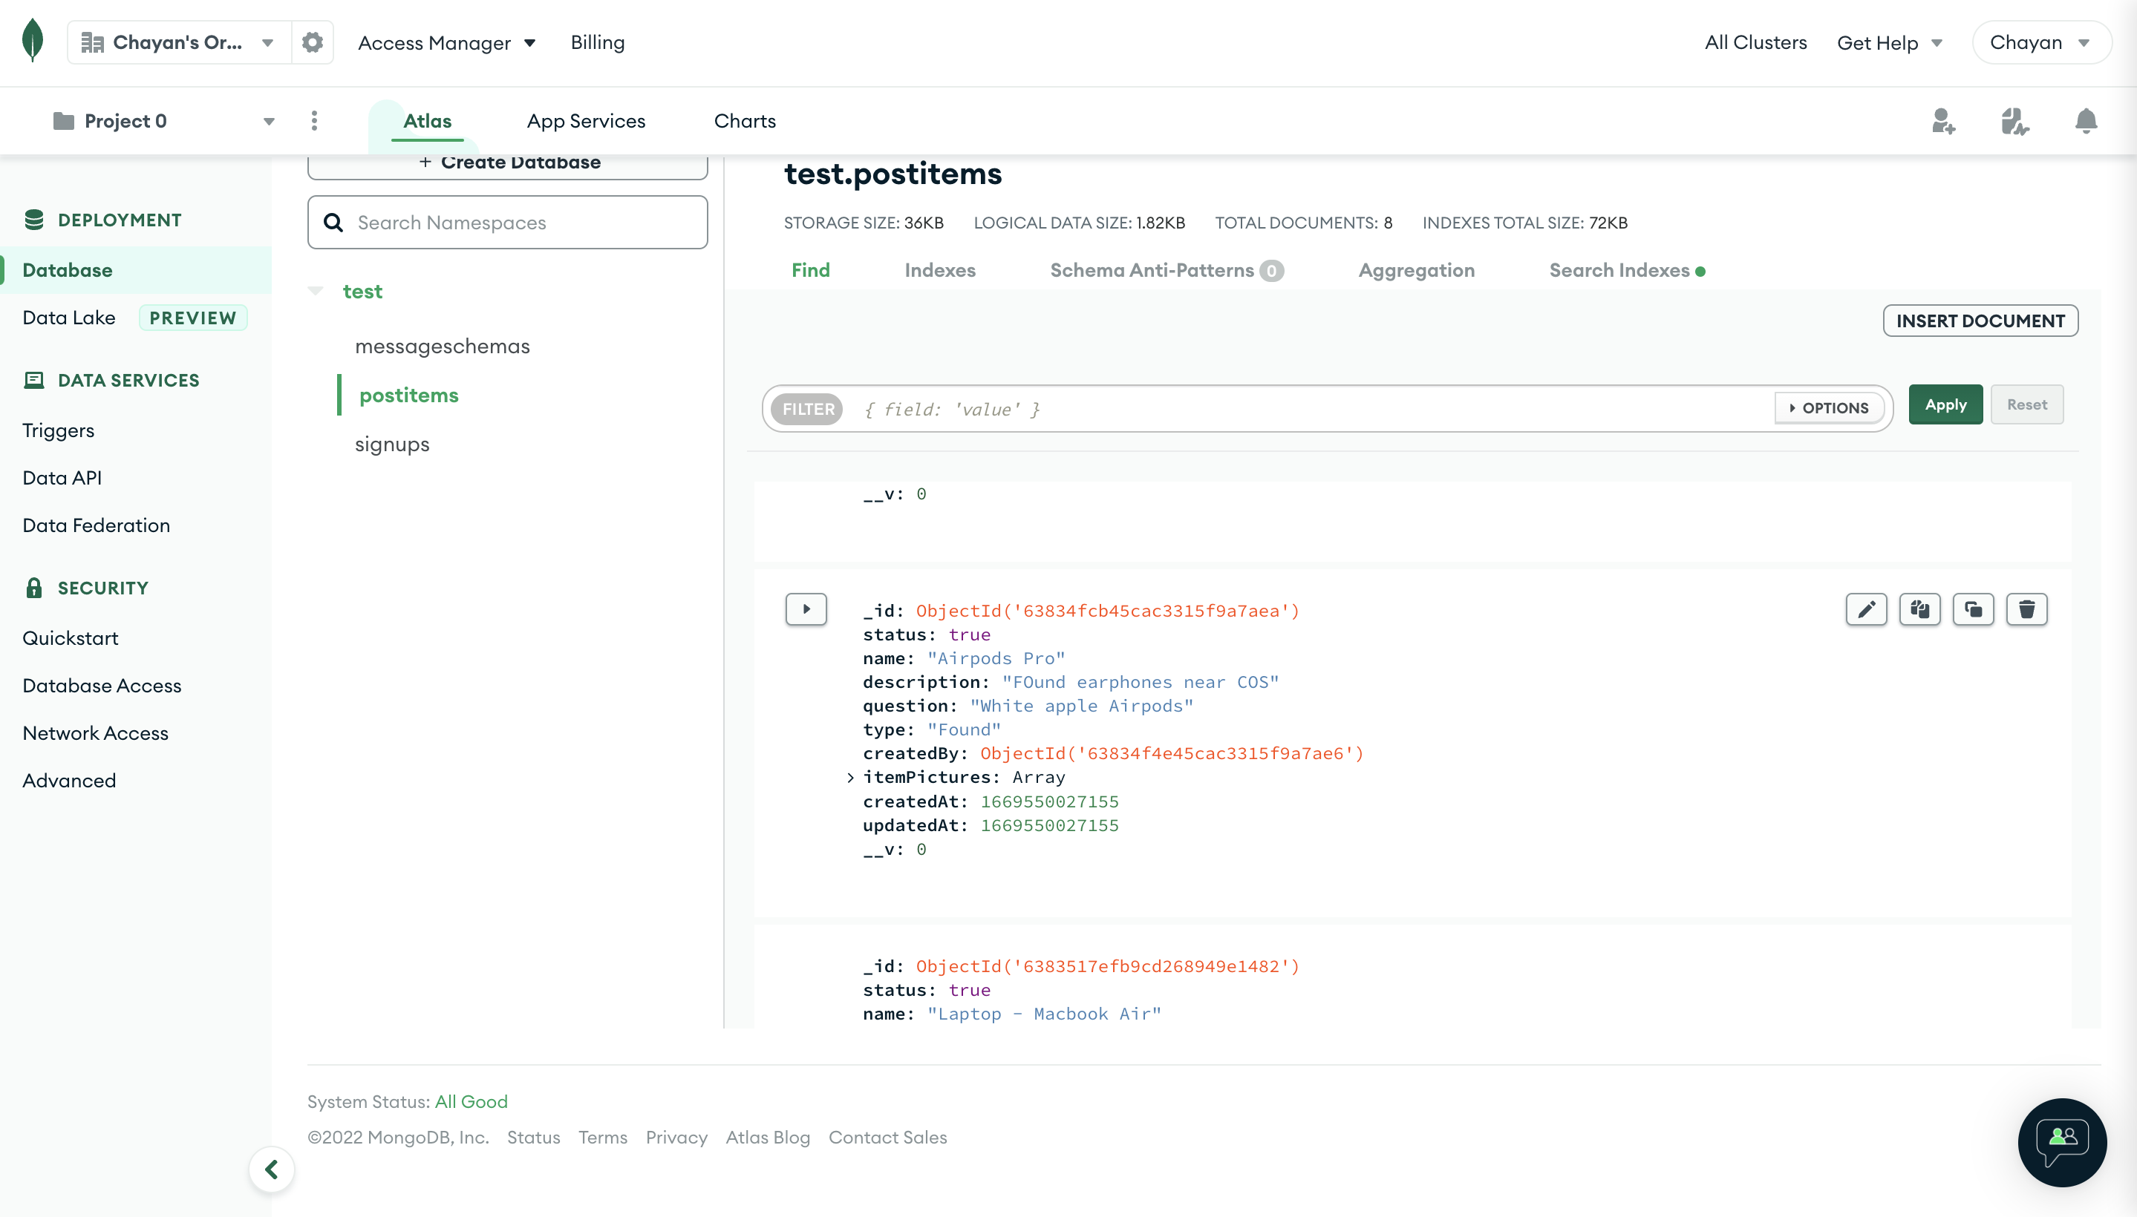

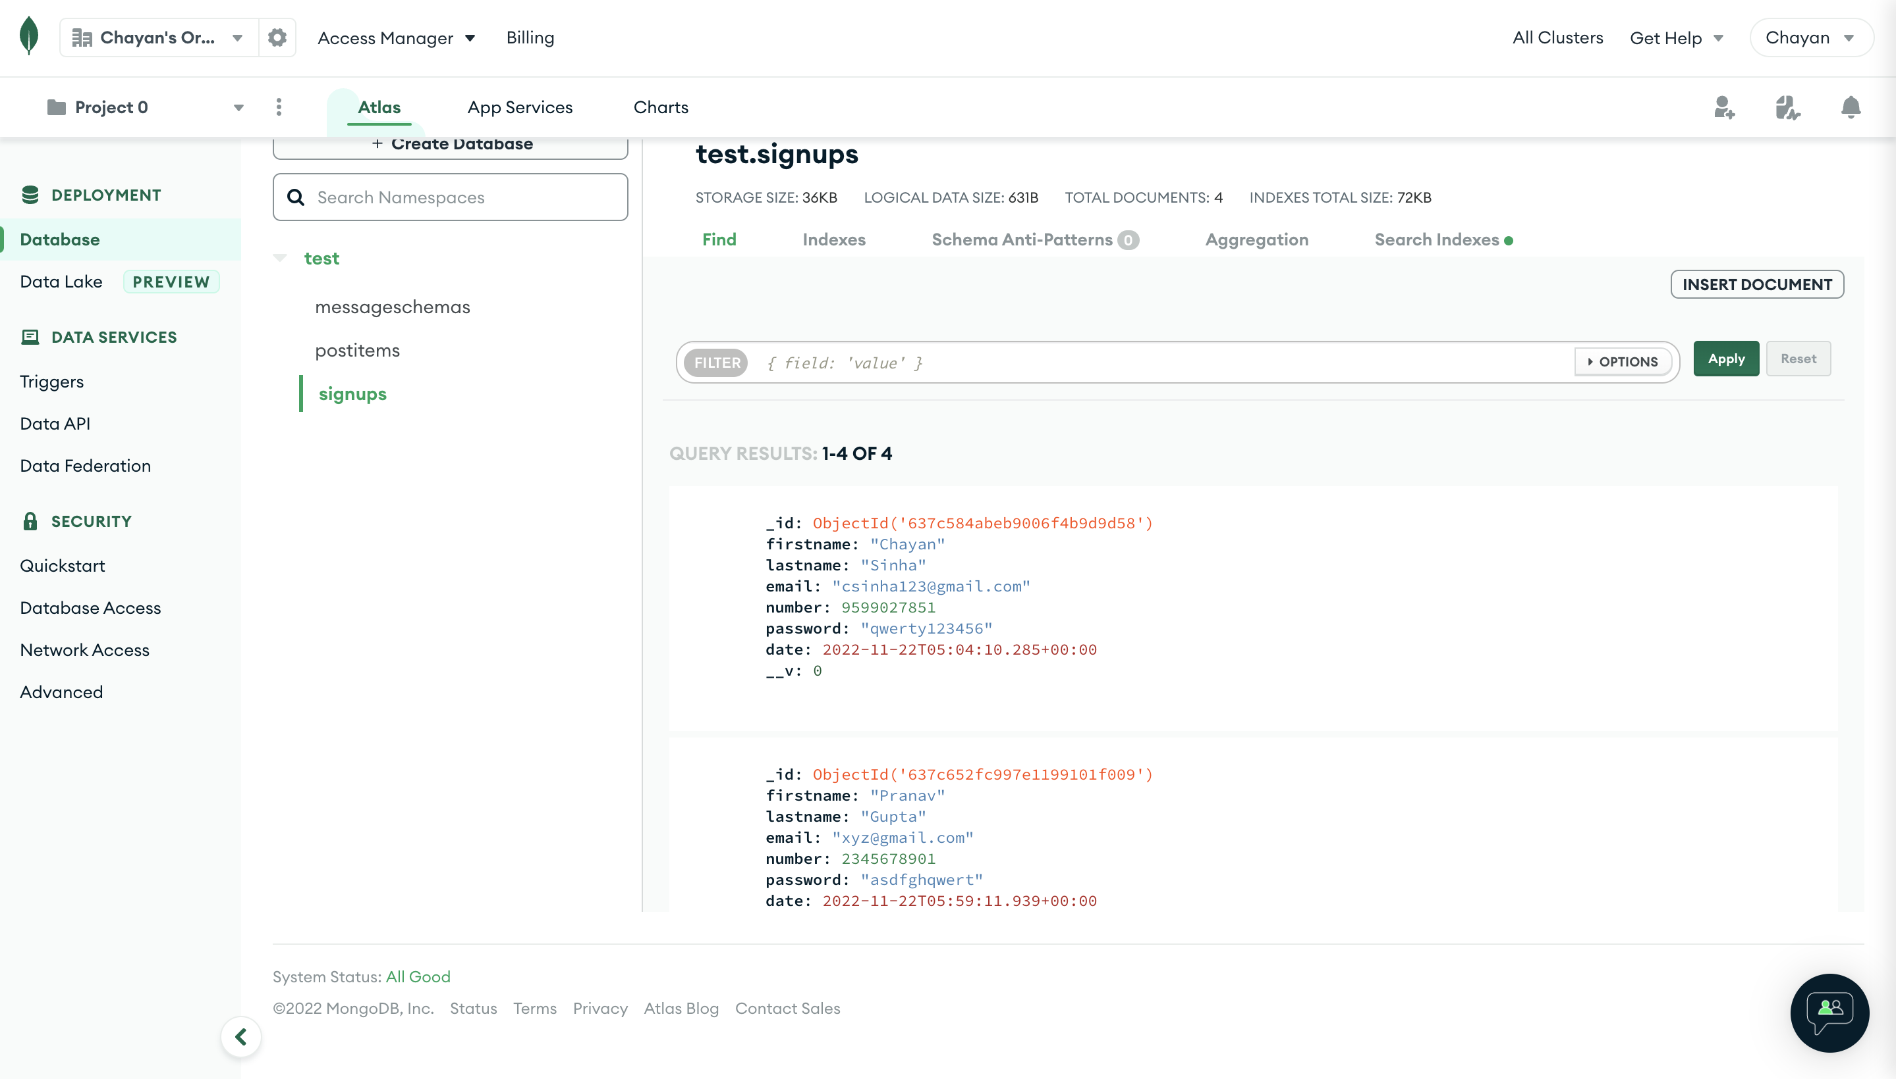

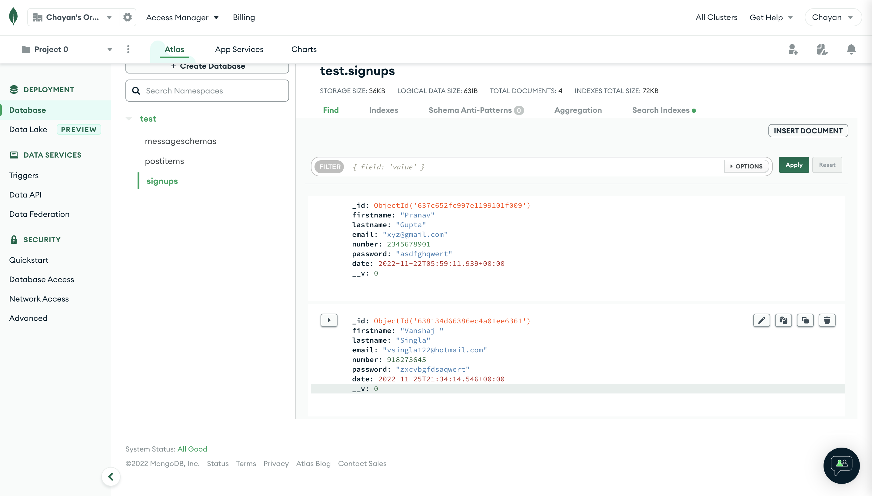

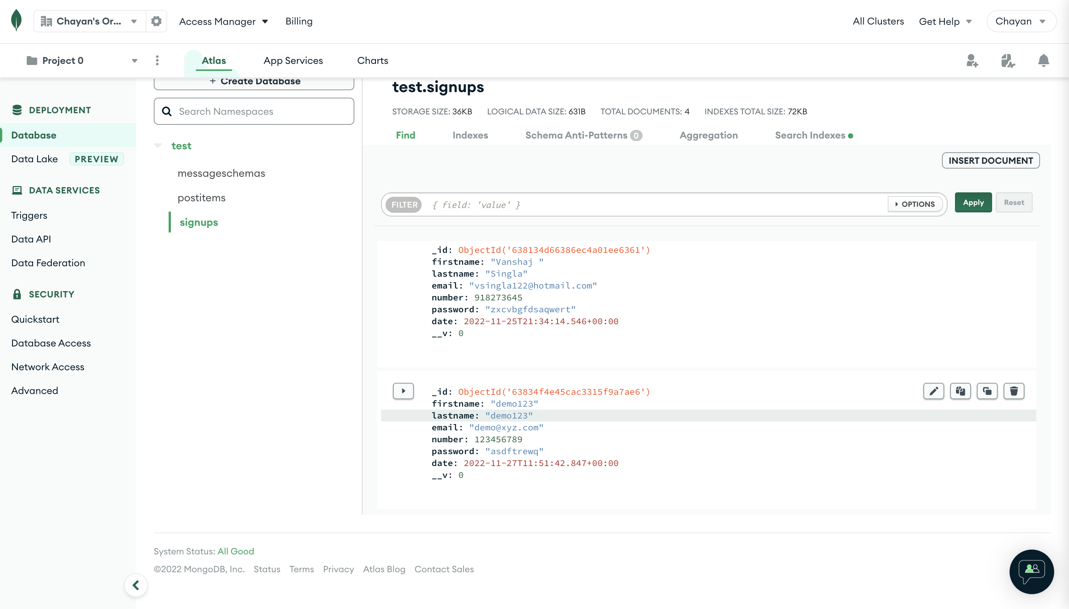

### 5. Testing

Test Case 1(simple test)

|  |  |
| --- | --- |
| **Test Case#:1** | **Test Case Name:** Login by userId for User |
| **System:** We_Secure website | **Subsystem:** Login |
| **Executed by:** Vanshaj Singla | **Execution Date:** 29/11/2022 |
| **Short Description:** Testing of member login | **Page: 1 of 3** |

**Pre-conditions**

● Consider the person should have a username and password

|  |  |  |  |
| --- | --- | --- | --- |
| **Step** | **Action** | **Expected System Response** | **Pass/ Fail** |
| 1. | Enter userId |  | PASS |
| 2. | Enter Password |  | PASS |
| 3. | Press Login button |  | PASS |
| 4. | **Check post condition 1** | Website should redirect the user to Services page/Feed Page and the instance should be stored in the database. | PASS |
|  |  |  |  |

**Post-conditions**

● Members logs in successfully and is directed to a new page “FEED” where they can select if they want to make an entry/exit, hostel or equipment request

**Since output was expected , the test case was successful.**

Test Case 2(simple test)

|  |  |
| --- | --- |
| **Test Case#:2** | **Test Case Name:**Lost Item |
| **System:** We_Secure website | **Subsystem:** Post Item |
| **Designed by:** Chayan Sinha | **Design Date:** 29/11/2022 |
| **Executed by:** Chayan Sinha | **Execution Date:** 29/11/2022 |
| **Short Description:** Testing of submitting the lost and found item by clicking on the Post Item | **Page: 2 of 3** |

**Pre-conditions**

● User must be a member and should have been logged in successfully and has previously allocated equipment.

|  |  |  |  |
| --- | --- | --- | --- |
| **Step** | **Action** | **Expected System Response** | **Pass/ Fail** |
| 1. | Enter the name of the equipment and other details |  | PASS |
| 2. | Press the “enter” button | After Clicking the enter button, the response should be saved and stored in the database. | PASS |
| 3. | **Check post condition 1** | Prints the message successfully listed the item | PASS |
|  |  |  |  |
|  |  |  |  |

**Post-conditions**

● Users cannot have any more items issued and can navigate back to the previous pages.

**Since output was expected , the test case was successful**

Test Case 3(simple test)

|  |  |
| --- | --- |
| **Test Case#:3** | **Test Case Name:** Modifying Request |
| **System:** We_Secure website | **Subsystem:** Update |
| **Designed by:** Karan Singla | **Design Date:** 29/11/2022 |
| **Executed by:** Karan Singla | **Execution Date:** 29/11/2022 |
| **Short Description:** Testing to update/modifying the item after submitting the latter. | **Page: 3 of 3** |

**Pre-conditions**

**●** User must be authenticated and should have been logged in successfully and should have posted a query

|  |  |  |  |
| --- | --- | --- | --- |
| **Step** | **Action** | **Expected System Response** | **Pass/ Fail** |
| 1. | Update the name of the article. |  | PASS |
| 2. | Update the item type. |  | PASS |
| 3. | Press the “SUBMIT” button |  | PASS |
| 4. | **Check post condition 1** | Prints “Item updated successfully” on the Output screen. | PASS |
|  |  |  |  |

**Post-conditions**

**●** Users cannot have any more updation and can navigate back to the previous pages.

**Since output was expected , the test case was successful.**